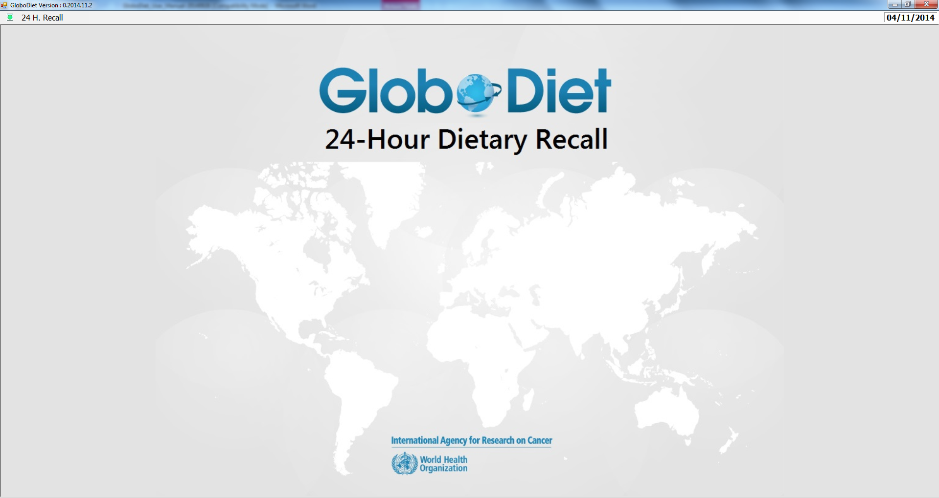

GloboDiet
USER’S MANUAL
Dietary Exposure Assessment Group (DEX)
International Agency for Research on Cancer

GloboDiet
USER’S MANUAL
Dietary Exposure Assessment Group (DEX)
International Agency for Research on Cancer

Lyon, France, May 2015

Any queries on the circulation, reproduction or other use of the material should be directed to:

Dietary Exposure Assessment Group
International Agency for Research on Cancer
150, cours Albert Thomas
69372 Lyon Cedex 08, France
slimanin@iarc.fr

This copy of the guidelines is part of the GloboDiet methodology and is protected as pre-existing know-how (PEKH) during and after the current project. Proper acknowledgement of the use of the GloboDiet methodology, including the GloboDiet guidelines, should be made in any document, report or scientific paper resulting from the use of this methodology. Like all IARC products disseminated for educational and research purposes, the entire GloboDiet methodology enjoys copyright protection in accordance with the provisions of Protocol 2 of the Universal Copyright Convention. All rights are therefore reserved.


We acknowledge the financial support of the European Community under the ‘Europe AgainstCancer’ Programme (Grant No. SOC 96 200416) and the FP6 EFCOVAL project (Contract number: FOOD-CT-2006-022895). The EC is not liable for any use of the information contained herein.
We also thank all for the contributors to this manual.

Changes in version May2015:
Changes made recently are highlighted in yellow. They mainly concern the following sections:

IV 3.5.2 Description with FACETS
- Explanation on how to go back to previous facets added
- Brand name can be edited in the field “Name”

IV 3.5.3.3 Mixed recipe pathways
- clarified

IV 3.6 QUANTIFICATION (sections 3.6.2 through 3.6.4)
- sections 3.6.2 through 3.6.3 were clarified and improved
- section 3.6.4: food classes for percent fat, sauce or sweetener were revised and updated

IV 3.9 MENUS AND FUNCTIONS AVAILABLE IN THE RECIPE INGREDIENT MANAGER screen(s) (to be used specifically for mixed recipes)
- Controls on recipe ingredient quantities better explained and some warning/error messages added.

IV 4 QUALITY CONTROLS
- Controls on recipe ingredient quantities added

V PROCEDURE FOR EDITING AN INTERVIEW
- Totally revised

Changes in version May2015: II
I. INTRODUCTION 1
II. THE COMPUTERIZED 24-HOUR DIET RECALL “GloboDiet” 3
1. GENERAL STRUCTURE OF GloboDiet 3
2. HARDWARE REQUIREMENTS AND INSTALLATION OF GloboDiet 3
2.1. HARDWARE REQUIREMENTS 3
2.2. Installation and un-installation of GloboDiet 3
2.3. HOW TO RUN GLOBODIET 3
2.4. HOW TO USE GloboDiet 4
3. BACKUP OF INTERVIEWS 6
III. RECOMMENDATIONS BEFORE STARTING THE INTERVIEW 7
1. Recommendations for Face-to-face interviews 7
2. Recommendations for telephone interviews 7
IV. PROCEDURE FOR ENTERING AN INTERVIEW 8
1. GENERAL INFORMATION ON INTERVIEWER, INTERVIEWEE AND THE DAY OF INTERVIEW 10
1.1 INTRODUCTION 10
1.2. DESCRIPTION OF THE SCREENS AND FIELDS 10
2. QUICK LIST 15
2.1 INTRODUCTION 15
2.2 DESCRIPTION OF THE SCREENS AND FIELDS 15
2.3 MENUS AND FUNCTIONS IN THE QUICK LIST SCREEN 19
2.4 SUMMARY OF THE PROCEDURE FOR COMPLETING THE QUICK LIST 19
3. FOOD/RECIPE DESCRIPTION AND QUANTIFICATION 20
3.1 INTRODUCTION 20
3.2 TYPE OF FOODS/RECIPES 21
3.3 GENERAL PROCEDURES 22
3.4 SEARCH/IDENTIFICATION 22
3.5 DESCRIPTION 24
3.6 QUANTIFICATION 31
3.7 CHECK FOR MISSING INGREDIENTS 37
3.8 MENUS AND FUNCTIONS AVAILABLE IN THE FOOD/RECIPE DESCRIPTION AND QUANTIFICATION screen 38
3.9 MENUS AND FUNCTIONS AVAILABLE IN THE RECIPE INGREDIENT MANAGER screen(s) (to be used specifically for mixed recipes) 39
3.10 SUMMARY OF THE PROCEDURE FOR COMPLETING THE FOOD/RECIPE DESCRIPTION AND QUANTIFICATION 43
4. QUALITY CONTROLS 46
5. VITAMINS AND OTHER SUPPLEMENTS 49
6. END OF THE INTERVIEW 52
V PROCEDURE FOR EDITING AN INTERVIEW 53
1. CHOOSE AN INTERVIEW IN EDIT INTERVIEW MODE 53
2. DIFFERENCES BETWEEN THE NEW AND EDIT INTERVIEW MODES 53
3. HANDLING OF NOTES 54
4. MODIFY A FCO 55
5. HANDLING OF RECIPES IN EDIT INTERVIEW MODE 56
5.1. Modification of a recipe 56
5.2. Specific case of OPEN recipes 58

I. INTRODUCTION

The 24-hour dietary recall is a dietary assessment method which consists of recalling what the subject ate and drank during the day preceding the interview. The interview can either be performed during face-to-face contact or by telephone. Information collected from the subject can be stored in different ways, for example, on paper, a precoded questionnaire, a tape recorder, or a computer programme.

The dietary information collected by the 24-hour recall method is more detailed than that obtained from “closed questionnaires” such as food frequency or dietary history questionnaires. A subject can quite easily remember what he/she consumed the previous day, and will be able to give detailed information about the specific types of food consumed (e.g. brandname of breakfast cereals), recipes and the ingredients used and the quantities of items consumed. However one of the main practical difficulties of this “open-ended” method is that it is not possible to know beforehand the foods which will be reported by the subject. The role of the interviewer is therefore essential because he/she needs to have a good knowledge of the study population’s food habits and to know the specific questions to be asked in order to describe and quantify correctly the foods or recipes which may be reported by the subject.

GloboDiet is menu-driven software developed to conduct a standardised interactive 24-hour recall diet interview in an international context. This computerized 24-h diet recall interview program (GloboDiet) was initially developed for use in a large-scale European multi-centre study, namely the European Prospective Investigation into Cancer and Nutrition (EPIC). It was developed by the International Agency for Research on Cancer (IARC), in collaboration with all national EPIC centres. It was adapted for each participating country and translated into local languages, to standardize interviews between the 22 EPIC centres (calibration method).

In brief, GloboDiet is an interview-based dietary assessment instrument that allows obtaining a very detailed description and quantification of foods, recipes, and supplements consumed in the course of the preceding day and thus standardising data within and between countries. Probing questions and entering consumed foods in chronological order support the respondent's memory. The standardized structure prescribes--on the food group level--possibilities of description and quantification of food items to choose from. Quantification of consumed foods is supported by the GloboDiet picture book that comprises coloured photographs of foods in different portion sizes. The software provides an automatic coding of food items and recipe ingredients as well as a rough calculation of nutrient intake meant for quality control of the interview. GloboDiet is characterised by the obtained standardization of dietary data within Europe, a large number of available foods and recipes, and a very detailed description of consumed foods. Currently, GloboDiet is one of the few dietary instruments providing comparable nutritional data within Europe.

Within the EFCOSUM project (European Food Consumption Methods), the GloboDiet programme has been recommended as the dietary intakes assessment method of preference for monitoring dietary intakes in pan-European monitoring surveys. Therefore, within the EFCOVAL project (European Food Consumption Validation), an EU sixth Framework project, pursued the EFCOSUM project, by adapting and validating the GloboDiet programme for use in pan-European monitoring surveys. One major improvement of the updated GloboDiet programme is its project-specific customisation.

Although this software has been designed in such a way that most of the rules and criteria for conducting the interview are already pre-defined and can be easily updated and adapted (e.g. list of foods or recipes, type and number of questions to be systematically asked in order to describe foods, quantification methods to estimate food or recipe portion sizes), the role of the interviewers remains essential to ensure the quality and the standardisation of the data collection. It is important that, before the interview, the interviewer should be well acquainted with GloboDiet and the related databases (e.g. food list, food or recipe classification systems, picture book...) and that the rules pre-defined in the software, indicated in the annex documents or mentioned during the local training course are strictly followed.

II. THE COMPUTERIZED 24-HOUR DIET RECALL “GloboDiet”

- GENERAL STRUCTURE OF GloboDiet

The GloboDiet 24-hour diet recall interview is structured in 5 main steps described in detail in the following chapters of part IV:

1. General information on the interviewer, interviewee and the recalled day
2. Quick list
3. Food/recipe description and quantification
4. Control at the nutrient level
5. Dietary supplement information

- HARDWARE REQUIREMENTS AND INSTALLATION OF GloboDiet

2.1. HARDWARE REQUIREMENTS

The minimum hardware requirements to run GloboDiet are a PC with Intel (or compatible) Pentium III, using Windows XP service pack 2 (or higher) with a minimum of 512 Mo of Ram and 600 MB of available hard disk space. A 15” screen with a resolution of 1024x768 (or higher) will also be necessary. The database system SQL server (express or not & 2005 or 2008) needs also to be installed.

2.2. Installation and un-installation of GloboDiet

Guidelines to install and remove the GloboDiet programme are described in detail in Appendix 3.

2.3. HOW TO RUN GLOBODIET

On your desktop, you can find the following GloboDiet icon that you will use to run GloboDiet.



Double-click this icon and the GloboDiet window below will appear:

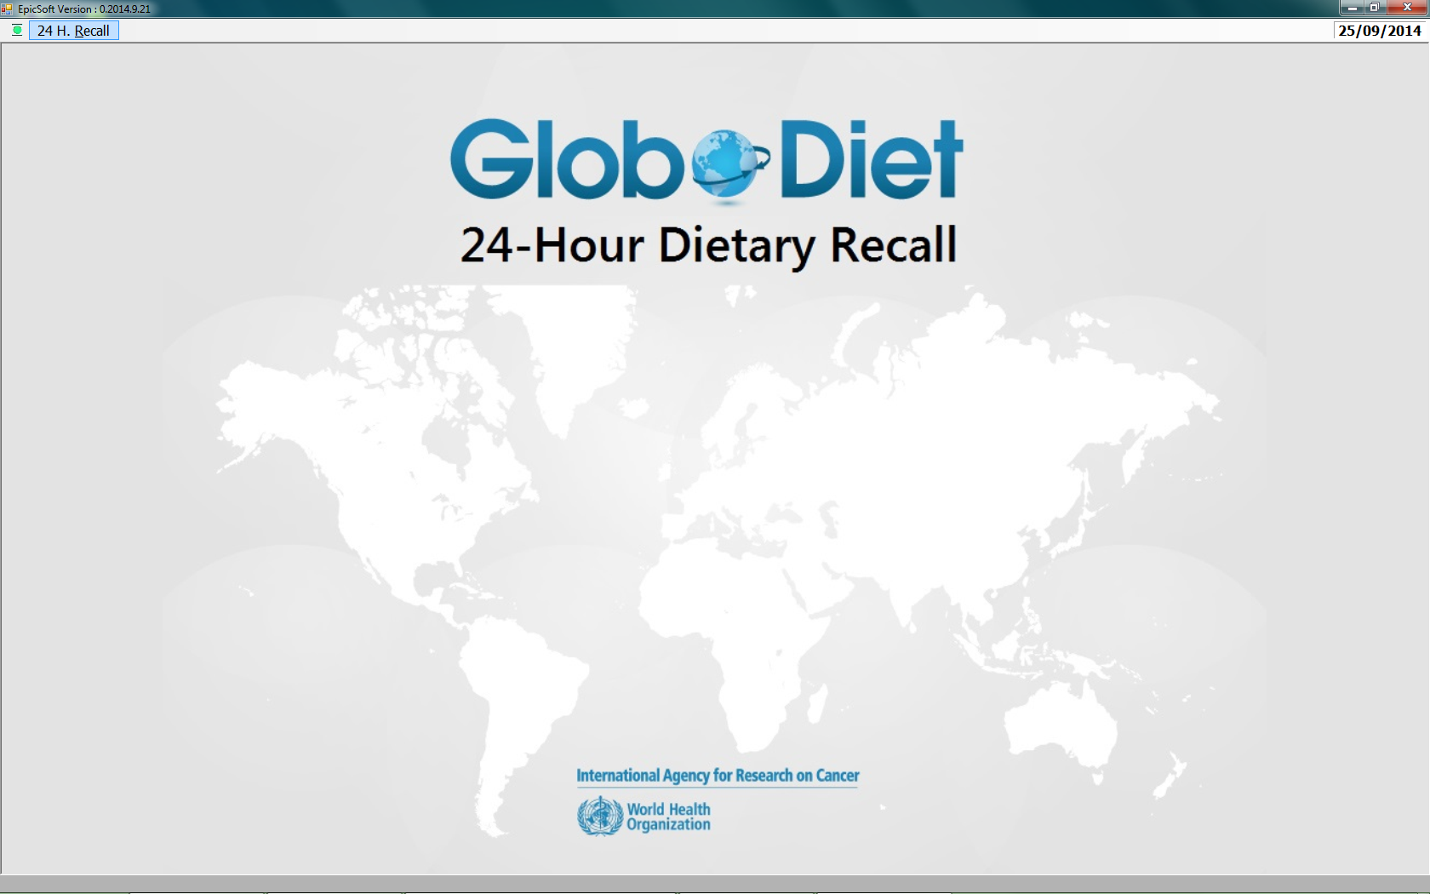

2.4. HOW TO USE GloboDiet

Before GloboDiet can be used, some basic operations such as how to execute a function, how to select an option, how to escape from a window etc. need to be known. Sometimes several possibilities for the same action are available (mouse, keyboard). These will be explained once in this chapter and will not be repeated in the rest of the manual each time they can be used. When the words SELECT or CONFIRM are indicated in the text, it means that one or a combination of the following possible options can be used.

2.4.1 Moving the cursor

Like in any other windows programme, the mouse can be used to move the cursor and to click the buttons. However, the arrows and enter button can be used to navigate through the screen and option lists as well.

* Use the UP-DOWN or LEFT-RIGHT ARROW-keys to move within a list or from one field to another available on the same screen.

* Use the TAB function to move from one window to another available on the same screen. To move upwards in windows or fields, use SHIFT-TAB.

* Use the mouse to move the cursor to the appropriate place and click the left button.

2.4.2 Select a menu or activate a function

* Most of the menus or functions which can be used on a current screen are available in a pull down menu. The pull down menu is accessed via the highlighted bar at the top of the window. Different methods can be used to access the menus and execute their corresponding functions:

- HOT-KEYS ALT: Some answers, menus or functions are accessible by means of a HOT-KEY which corresponds to the character either in brackets ‘[]’, or underlined in the label, or the first capital letter of the label (e.g. Alt-O for OK or Alt-V for View menu). Hold down the Alt-key and press the highlighted character of the menu or function. This will not work when the option is not relevant/activated.

- KEY functions: Some functions are also accessible with a KEY-function (e.g. F4 for the function ADD INGREDIENT). Push the corresponding key at the top of your keyboard (a list of key functions can be found in Appendix 2).

- Keyboard: Position the cursor on the field of the menu or function by means of the ARROW-keys or the mouse and press RETURN to confirm the selection.

- Mouse: Position the cursor on the field of the function with the mouse and click the left button to select it: click once to select a function, double click to select an option from a list or to open a window. Right click to see the options/menu, the proposed list is the merge of the different menu functions, then left click to select the function.

* The functions available at the bottom of the screen are accessible with both their KEY functions and the mouse:

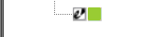
- F1 (NOTES): This function allows the interviewer to enter notes at any time during the interview. The presence of notes attached to an item is flagged by an additional square in front of the green square (if food), or the blue square (if recipe).

- ALT FI (SHOW ALL NOTES): This function allows the interviewer to view all the notes at any time during the interview.

- F2 (TIME): This function gives the duration since the beginning of the interview, i.e. when NEW interview is chosen (not in EDIT interview mode).

- F3 (INFORMATION): This function makes it possible to EDIT or MODIFY the screens for interviewee data, recalled day and wake up time at any time during the interview.

2.4.3 Select an option from a list

An option from a list (e.g. food list) can be selected by:

- Keyboard: Position the cursor on the option using the ARROW-keys and press RETURN to confirm the selection.

- Mouse: Position the cursor on an option and double click to select it.

If more than one option can be selected from a list (e.g. in the “source”, “flavoured/added component” or “enriched/fortified” facets), tick boxes are proposed on the screen. The selection/un-selection can be made by:

- Keyboard: with the space-bar.

- Mouse: double click with the mouse

A ticked box in front of each descriptor confirms the selection – The selected descriptors are listed on the right side of the window. To exit you have to click on ‘OK’.

2.4.4 Close or escape from a window or a screen

Confirm the information by selecting the OK function.

Escape from the current window by using the ESC key or select the "close window" (box with cross) available at the top right corner of the current window.

- BACKUP OF INTERVIEWS

In GloboDiet, regular backups are done to prevent all the information already entered from being lost if the interview is interrupted. When the software is reconnected, after a breakdown or power cut, a warning message indicates to the user that a pending interview has been detected. The interview can then be resumed at the place where it was just before the interruption, by selecting the option RESUME available in the 24 H. RECALL menu.

The GloboDiet methodological platform will enable to handle the interviews and their notes. In GloboDiet, some functions related to the ‘Set up’ are available to import, export/back-up and remove Interview database. This is the topic of Appendix 4. GloboDiet Database Management also available for the coordinators.

III. RECOMMENDATIONS BEFORE STARTING THE INTERVIEW

Depending on the administration method, some specific recommendations should be considered before starting the interview.
- Recommendations for Face-to-face interviews

Face-to-face interviews can be carried out in a study center, in which case the participant will be asked to visit the center to take the 24h dietary recall interview. However, this interview might also be taken at the home place of the participant. In any of those two cases, it is very important that the interviewer introduces him/herself to the participant and explains briefly the aim of his/her visit. Introduce yourself as a research worker of the study, and tell the interview will last approximately 20-60 minutes and that the interview is entered at the same time in the computer. Make sure that the participant can make himself feel comfortable.

- Recommendations for telephone interviews

Be seated in a quiet surrounding and ask the participant to do the same (as far as possible). Tell the participant that the interview will take approximately 20-60 minutes and that the interview is entered in the computer at the same time. Noise, sounds of radio and TV, etc. will possibly disturb the conversation and have to be avoided.
Introduce yourself as a research worker of the study and make clear that you are calling him/her concerning the study. Ask if the participant has the photo book at hand. If the participant has no photo book, the interview should be carried out and this should be mentioned to the coordinator of the study.
At a telephone interview the answers of participants can be influenced by the presence of third parties. Third parties can interfere with the conversation, by taking the word or "to improve" the answer. As an interviewer, be cautious that a third person does not take over the conversation of the participant. If someone else has prepared the meals, the participant can obtain information from this person. This is not necessary. If the person who prepares the meals is not present at that time, the interview can be conducted anyway.
The participant is allowed to look in the cupboard or fridge to obtain the information necessary for the interview. The interviewer must however watch that the interview is not interrupted too frequently.

IV. PROCEDURE FOR ENTERING AN INTERVIEW

- Double click the GloboDiet icon

- Confirm the "CURRENT DATE", or change the date by typing the correct date

Menu of the upper left corner green icon

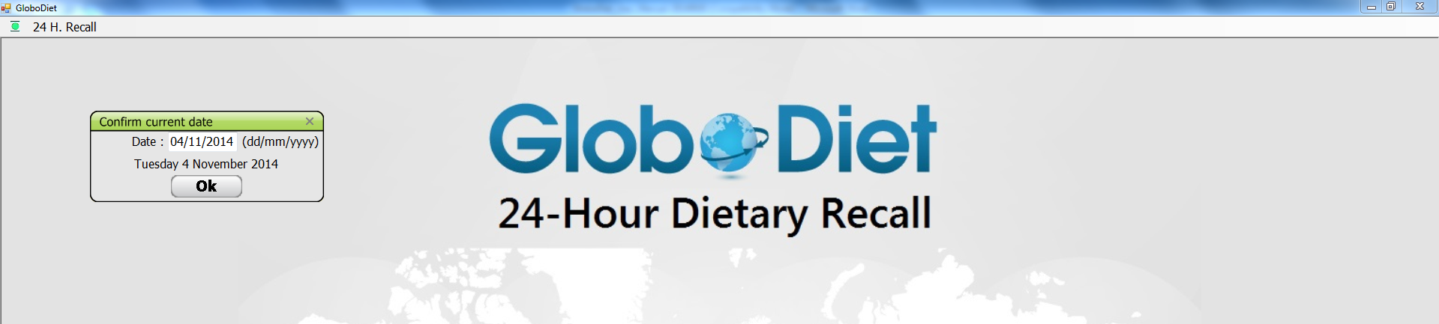

* Setup:
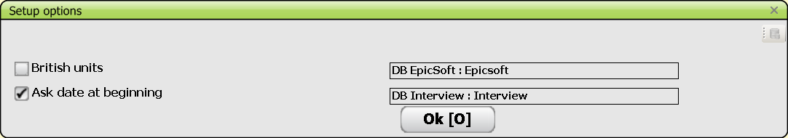

- British units: can be activated by ticking the box. (£).

- Ask date at the beginning: enables to activate/desactivate the question on the current date

- The names of the active DB sets are indicated.

* Load subject list (Ctrl L): enables to load into GloboDiet an Excel file containing a pre-entered list of subjects, prepared for a given interviewer. F5 allows viewing the interviewee list and selecting from it.

* Interview databases See Appendix 4 for the database management
* GloboDiet parameters databases

* About (Ctrl F1): copyright of GloboDiet

Menu "24 H. RECALL": select one of these options

* NEW INTERVIEW (to proceed with a new interview)

* EDIT INTERVIEW (to edit an interview already performed)

* RESUME INTERVIEW (to edit an interview interrupted after a breakdown of the software)

(£): In addition to the international units (cm, Kg, L) used by default during the interview, Imperial units (feet, inch, stone, pound, ounce, gallon, quart and pint) can be selected. These British units can be used both to enter the interviewee’s weight (feet and inches) and height (stone and pounds), and when the WEIGHT and VOLUME quantification methods, which allow the portion weights or volumes known by the subject to be entered manually, are selected. If Imperial units are used during the interview, they are automatically converted into grams and both modes of expression are visible on the screen.
Even if GloboDiet is closed, when you open it, the selection is still active.

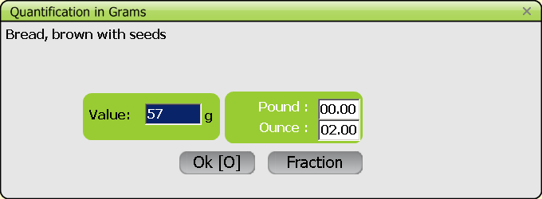

A reminder of some function keys is indicated at the bottom of the screen once the interview has started. They may also be activated by double clicking on them at the bottom of the screen.

- F1: enables to enter a note. ‘General notes’ are not linked to a specific food/recipe/dietary supplement or QLI, unlike ‘Specific notes’. ‘View all notes’ is also proposed.

- Alt F1: available from the QUICK LIST step, enables viewing all notes

- F2: enables to view the elapsed time since the beginning of the interview in NEW INTERVIEW mode (not in EDIT INTERVIEW mode)

- F3: enables to view and/or modify the interviewee data during the interview. Select ‘Modify’ or ‘OK’, the latter enables to leave the interviewee data screen and go on the previous task.

- F5: only available at the very beginning of the interview, allows viewing the interviewee list and selecting from it.

- GENERAL INFORMATION ON INTERVIEWER, INTERVIEWEE AND THE DAY OF INTERVIEW

1.1 INTRODUCTION

The general information collected at this stage, on the interviewer, interviewee and the day of interview, will be used both to keep track of the person who performed the interview and on the subject interviewed, as well as to make some checks during and after the interview. For example, the data on age, sex, height and weight are used to calculate the energy requirements of the subject which are compared, at the end of the interview, with the energy intake as estimated from the 24-hour recall interview (see the chapter on the quality controls). The subject is asked to give general information on the day recalled, in order to identify whether or not the subject was on a special diet (e.g. the subject follows a diet or medical treatment), or the day recalled was a special day because of religious celebration, travel, ...

It is noteworthy that the user can always use the mouse similarily like it is being used in other Windows programs. However, because of practical reasons, this Windows method will not be elaborated in this manual and only the keyboard functions will be mentioned below.

1.2. DESCRIPTION OF THE SCREENS AND FIELDS

Date confirmation

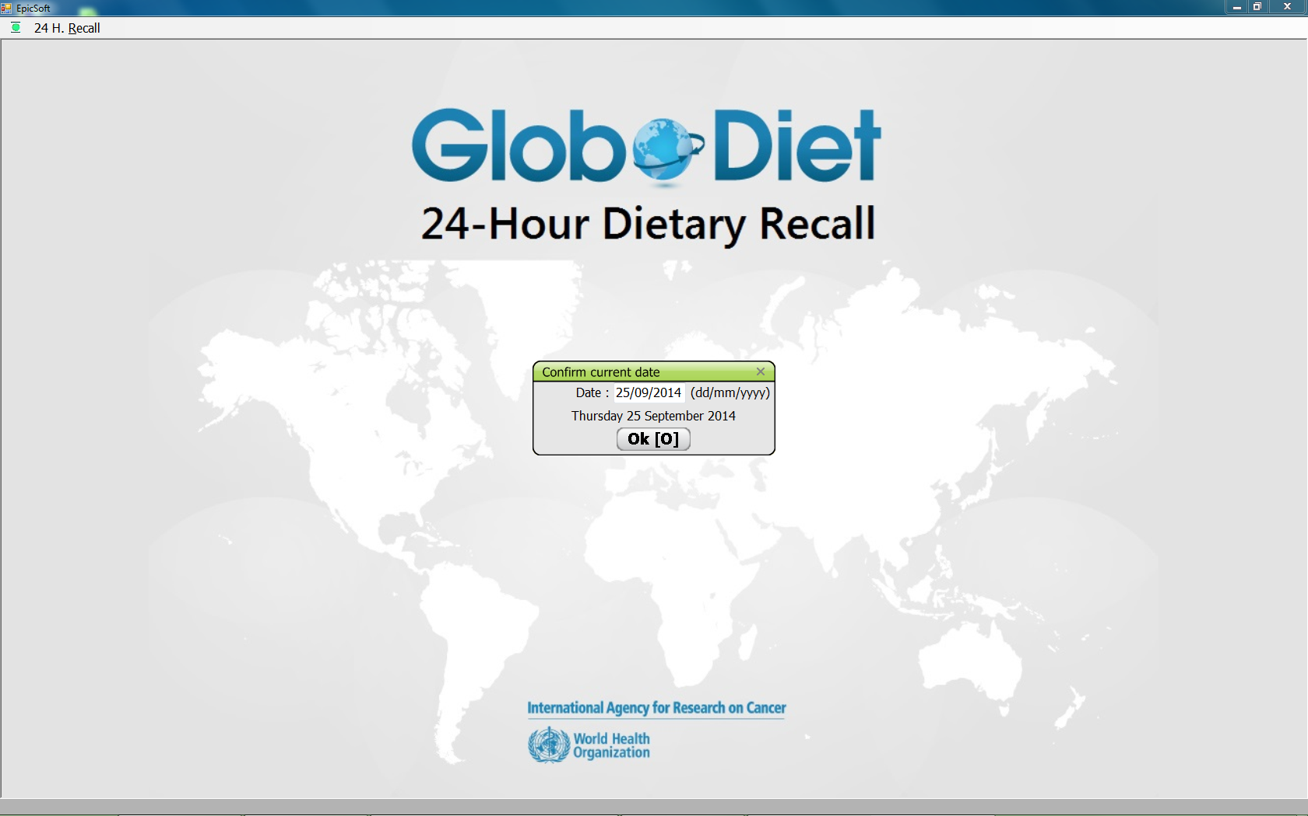

CENTER (COUNTRY) LIST screen
When you first connect, you first have to select your country. If you are using the UK test version, please select one of the UK centers.

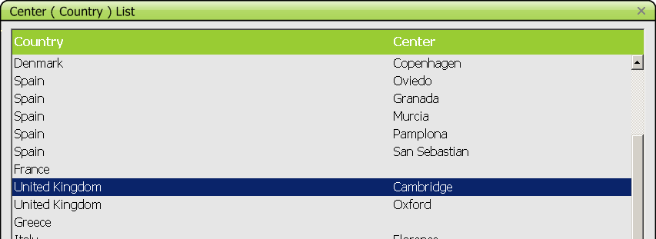

INTERVIEWER DATA screen
Then select the name of the interviewer from the pre-defined list.

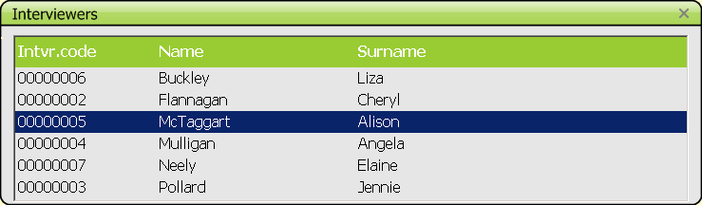

Note: This information will be kept as default so the interviewer name will be proposed the next time you open GloboDiet. Before starting the interview, confirm the name of the interviewer. If it is not correct, reply NO to the question and select the correct centre and name of the interviewer from the pre-defined lists.

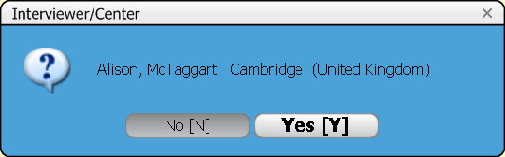

INTERVIEWEE DATA screen
Then information concerning the subject has to be entered.

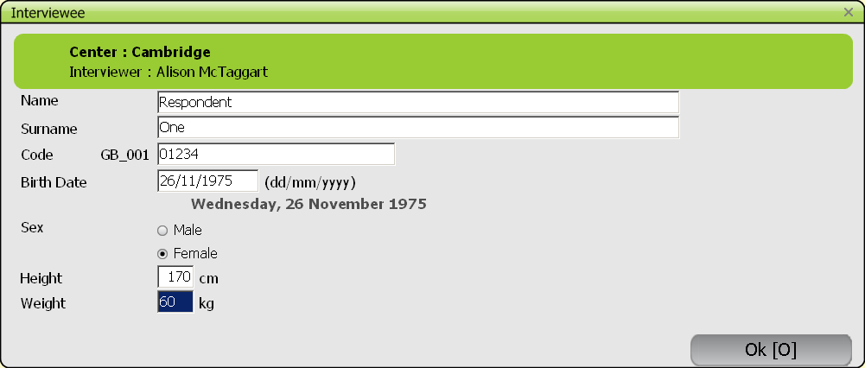

Fill in each of the fields appearing on this screen (e.g. NAME, SURNAME):

* Manually: enter manually the information in each field and confirm by pressing RETURN/TAB/ arrow DOWN.

* Automatically: All the information about the interviewees (or part of it) can be stored in a pre-defined file and can be accessed by pressing the F5 key. Select the subject to be interviewed from the "LIST OF THE INTERVIEWEES" screen and the pre-entered information regarding this subject is automatically displayed in the respective "INTERVIEWEE DATA" fields.

- The subject identification code may contain numbers as well as characters. The country and center codes (here GB_001) are pre-entered by the system.

- For the variable "SEX": Select the MALE or FEMALE option.

Be aware that checks are made on the variable ‘birth date’:
- If (calculated) age > Age_max or (calculated) age < Age_min then a WARNING message pops up – but you can proceed to variable ‘sex’ or update the birth date
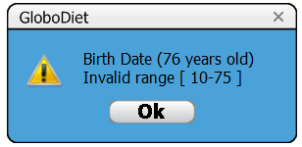

- If (calculated) age > 150 or < 0 then it is handled as an ERROR with a message and return to fill in the birth date.
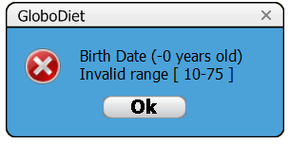
Checks are also made on the height and weight as WARNINGs. If height and weight are unknown, the interviewer should enter “999”; default figures will be used to calculate the energy requirement needed for the final control screen.

- Confirm with the ‘OK’ button to exit the screen.

RECALLED DAY AND WAKE UP TIME screen

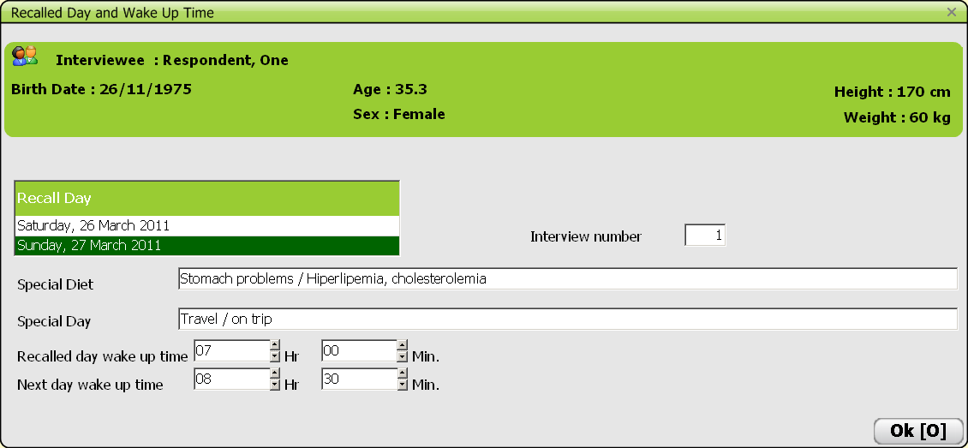

a. RECALLED DAY field
The two days before the date of the interview are shown on the screen, allowing a 24 hour or 48 hour recall interview (e.g. Saturday recalled on Monday). Select the date corresponding to the recalled day.

b. INTERVIEW NUMBER field
The interview number corresponds to a sequential number of interviews for the same subject (1st, 2nd, etc…). This variable is entered just for information.

c. SPECIAL DIET or SPECIAL DAY fields
Predefined lists are prepared at the project level for harmonisation reasons. The SPECIAL DIET is the regular diet, the SPECIAL DAY relates to the interview day as compared to regular days.
To select a (or several) Special diet or day, the user needs to press the ENTER button (or double-click the left mouse key) to access the predefined list. To select the options the user can use the mouse (like in other Windows applications) or can use the arrows in combination with the space bar.
When selecting the option ‘other’, the user has the possibility to specify that other special day/diet in the field ‘Other’.
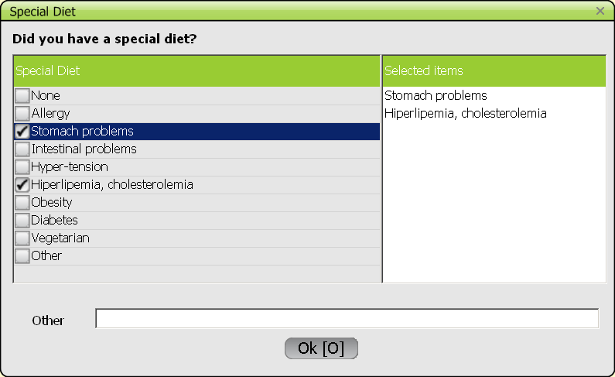

d. RECALLED DAY WAKE UP TIME or NEXT DAY WAKE UP TIME fields.
Manually report the hour and minutes of the consecutive wake up times in the two corresponding fields and confirm with the ‘OK’ button to exit the screen/window. The wake-up times must be expressed in the interval 0-24 hours, the use of a.m./p.m. is not allowed.

When completed, GloboDiet automatically proceeds to the quick list step. To view and/or modify the interviewee data during the interview, press F3 and select ‘Modify’ or ‘OK’, the latter enables to leave the interviewee data screen and go on the previous task.

Note: Some features of the screens are parametrable and will depend on the project coordinator’s decisions.

- QUICK LIST

2.1 INTRODUCTION

The QUICK LIST is an open-field where all foods/recipes consumed by the subject at the different moments of the day are noted, strictly following the chronological order of the day. For recognition purpose, it is advised to follow this chronological order during the interview. For each pre-defined food consumption occasion (BEFORE BREAKFAST to DURING THE EVENING/AT NIGHT), the foods consumed by the subject are reported in generic terms (the so-called QUICKLIST ITEMS: QLI), without being described in detail or quantified. An additional field at the bottom of the screen enables to report any dietary supplement.

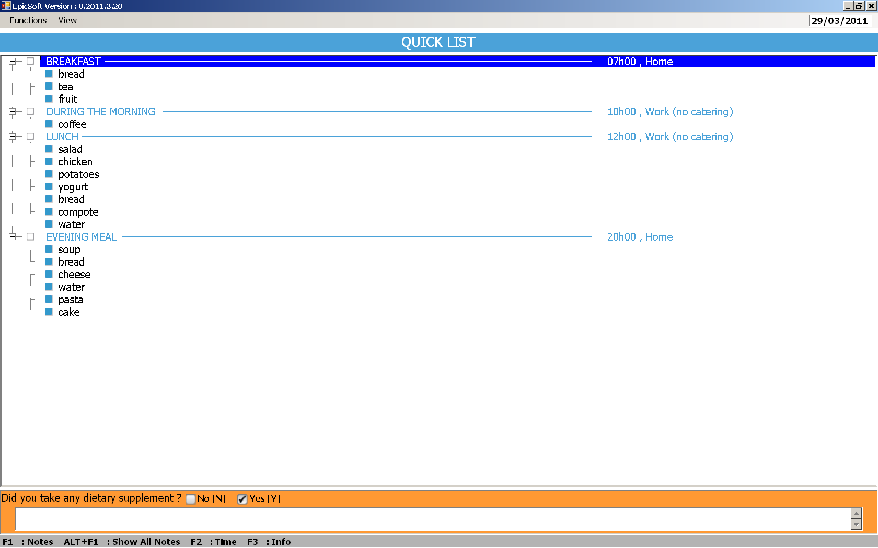

2.2 DESCRIPTION OF THE SCREENS AND FIELDS

FOOD CONSUMPTION OCCASION (FCO) window (#1)
Before going into the QUICK LIST, the FCO selection window appears, with the options of select (SELECT), go to the next (NEXT), or return to a previous (PREVIOUS) FCO. An additional option (EXIT QUICK LIST) is available on the last FCO of the day (DURING THE EVENING/AT NIGHT). This option will be used in order to leave the QUICK LIST and go to the DESCRIPTION AND QUANTIFICATION step. Every FCO can be selected once, except for “during the morning”, “during

the afternoon” and “during the evening” that can be selected more than once (though this depends on the parameters chosen by the coordinator).

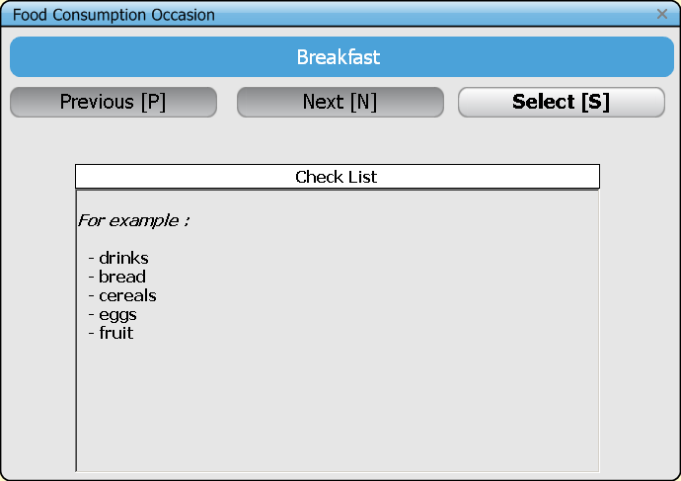

CHECK LIST window
For every FCO available, a window with a checklist opens under the FCO window, containing foods usually eaten at that occasion and that may be forgotten. This list is country-specific.

FOOD CONSUMPTION OCCASION window (#2)
A screen opens after a specific FCO (here ‘Breakfast’) has been selected.

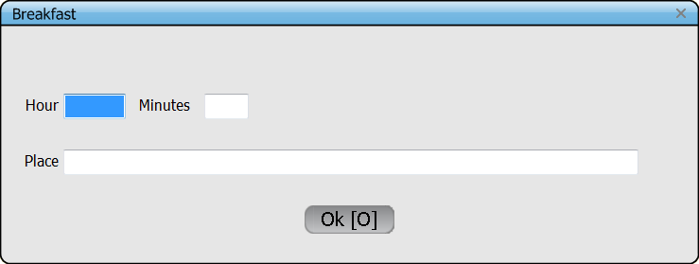

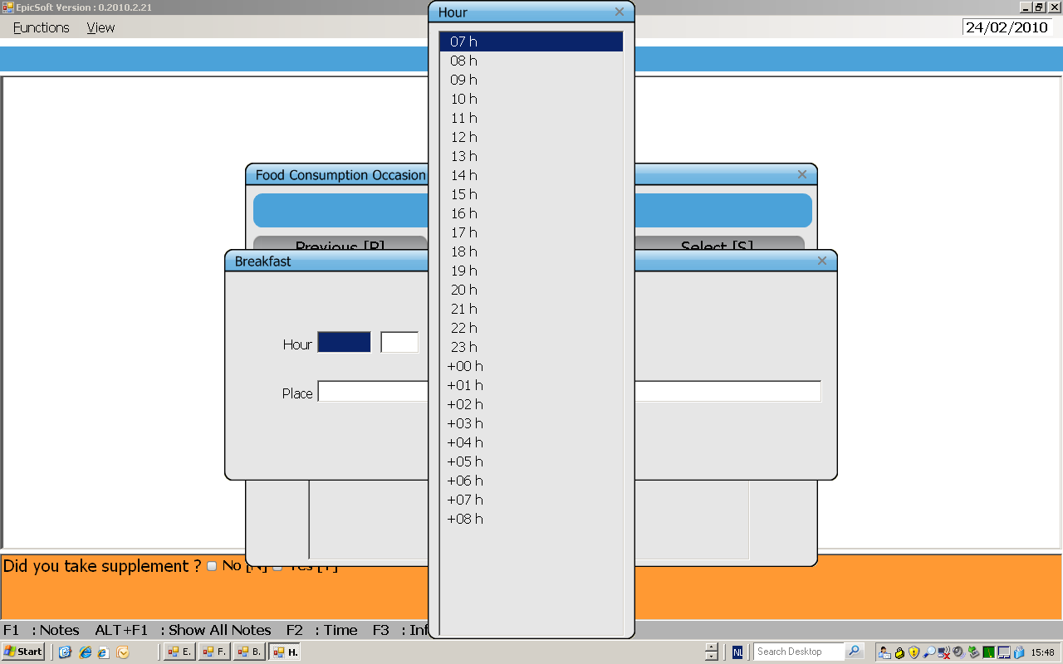
Complete the information on time and place of consumption from the predefined lists:

Note that the time can be easily entered directly without selecting from the predefined list.

Other places of consumption can be entered by selecting ‘Other’ in the predefined list, then writing information in the field ‘Other’ at the bottom of the pop up. The entered data is stored in the Note file.
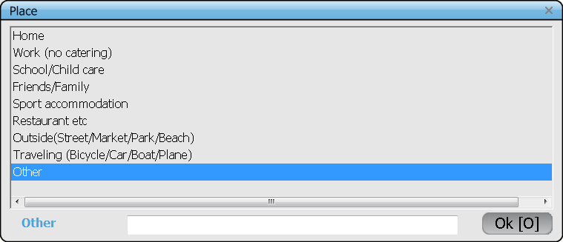

- Confirm with the ‘OK’ button to exit the window.

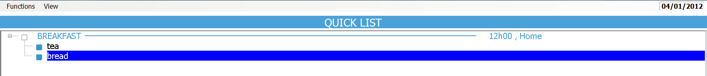
QUICK LIST-screen

Information on the name, time and place of each FCO indicated in the two previous food consumption occasion windows, is reported on the screen as a header starting by a white square. All the foods/recipes (quick list items) consumed by the subject for each FCO should be reported under each respective header. Each line should be confirmed by a return. Once the list for a FCO is completed, go to the next FCO (see section 2.3).
Tip: Extra information can be reported in brackets behind the name of the quicklist item. For example, if the subject says that he consumed 2 SLICES OF BREAD for a given FCO, you can write BREAD as a quick list item, and write into brackets the quantity (2 SLICES).

N.B.: fats, sauces and sweeteners should not be listed in the quick list. They will be probed for during the description/quantification step. That will enable to use standard percentages in case their quantities are unknown by the subject.

QUICK LIST CHECK screen
When the option ‘Exit Quick List’ is selected, the Quick list check screen shows up. The left hand column ‘FILLED’ contains the FCOs filled during the Quick list step, the right hand column ‘EMPTY’ lists those skipped. The small column in the middle flags by ‘**’ the FCOs mentioned during the Quick list step and kept empty. Those should be either removed from the quick list or filled in. The ‘OK’ button enables to proceed with the interview.
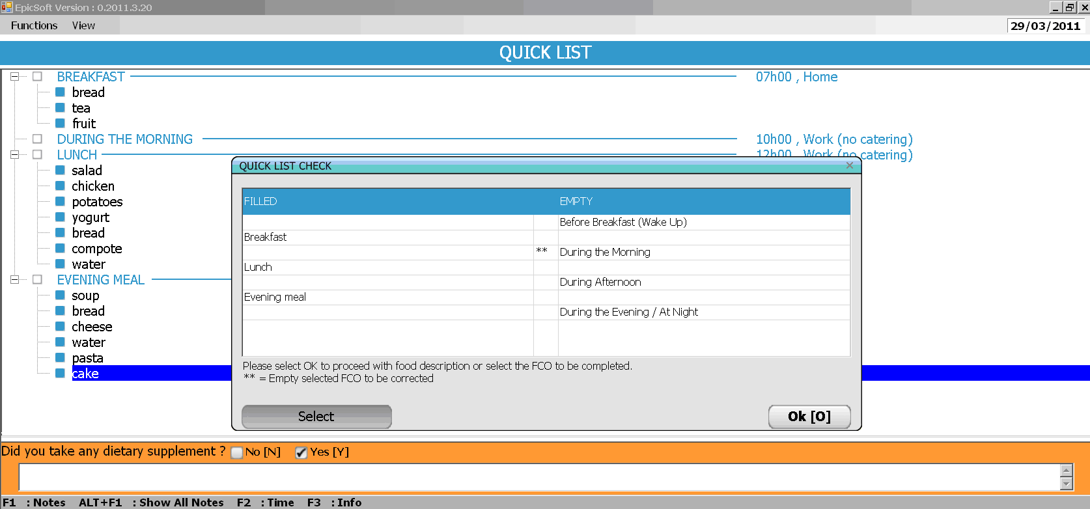
The ‘Select’ button enables to access a FCO the cursor is on. Double click on a FCO also enables to access the Quick list and fill (or delete) this FCO.

2.3 MENUS AND FUNCTIONS IN THE QUICK LIST SCREEN

FUNCTIONS menu

* NEXT OCCASION (F5): To go to the following FCO, when the list of quick list items (QLIs) attached to a given FCO is completed.

* ADD ITEM (F4): To insert a new quick list item (QLI) in a list of items already completed. The new line is created under the line on which the cursor is focused.

* EDIT/MODIFY (F8): To modify QLIs or FCOs already entered. The option is active on the QLI or the FCO on which the cursor is focused. For the FCO, you can change the time and place of this FCO. For the QLI, you can enter another QLI which replaces the previous one.

* DELETE ITEM (F6): To delete a QLI or a FCO already entered. The option is active on the QLI or the FCO on which the cursor is focused.

* DESCRIPTION/QUANTIFICATION (F9): To go from the quick list to the following "description/quantication" phase. Press the F9 key again to move back to the quick list. However, this option is active only if the interviewer went through all the FCO’s of the quicklist, and EXIT QUICK LIST has been chosen.

VIEW menu

* EXPANDED (F7): To display the information on the screen in expanded form (default). The name, hour and place of the FCOs, and the QLIs attached to each of them are reported on the screen.

* COMPRESSED (ALT-F7): To display the information on the screen in compressed form. Only the name, place and hour of consumption of the selected FCOs are reported on the screen.

2.4 SUMMARY OF THE PROCEDURE FOR COMPLETING THE QUICK LIST

* Select a FOOD CONSUMPTION OCCASION (FCO)

* Complete time and place of the FCO

* Report on the QUICK LIST screen the foods/recipes (quick list items)- no fats, sauces or sweeteners. The dietary supplements consumed by the subject may be entered in parallel in the note field at the bottom of the QUICK LIST screen at any moment

* Go to the next FCO

* Once the day is completed, go to the last FCO (DURING THE EVENING/AT NIGHT), and select the option EXIT QUICK LIST to go to the description/quantification step

* Confirm and exit the QUICK LIST CHECK screen displayed, if no flag ‘**’ remains on this screen. Else clean the QUICK LIST.

- FOOD/RECIPE DESCRIPTION AND QUANTIFICATION

3.1 INTRODUCTION

At the stage of the FOOD/RECIPE DESCRIPTION AND QUANTIFICATION, each of the items reported in generic terms in the quick list (quick list items) is identified and described, and quantified according to pre-defined rules.

Four main steps can be distinguished:
- search/identification,
- description,
- quantification,
- check for missing ingredients and probes.

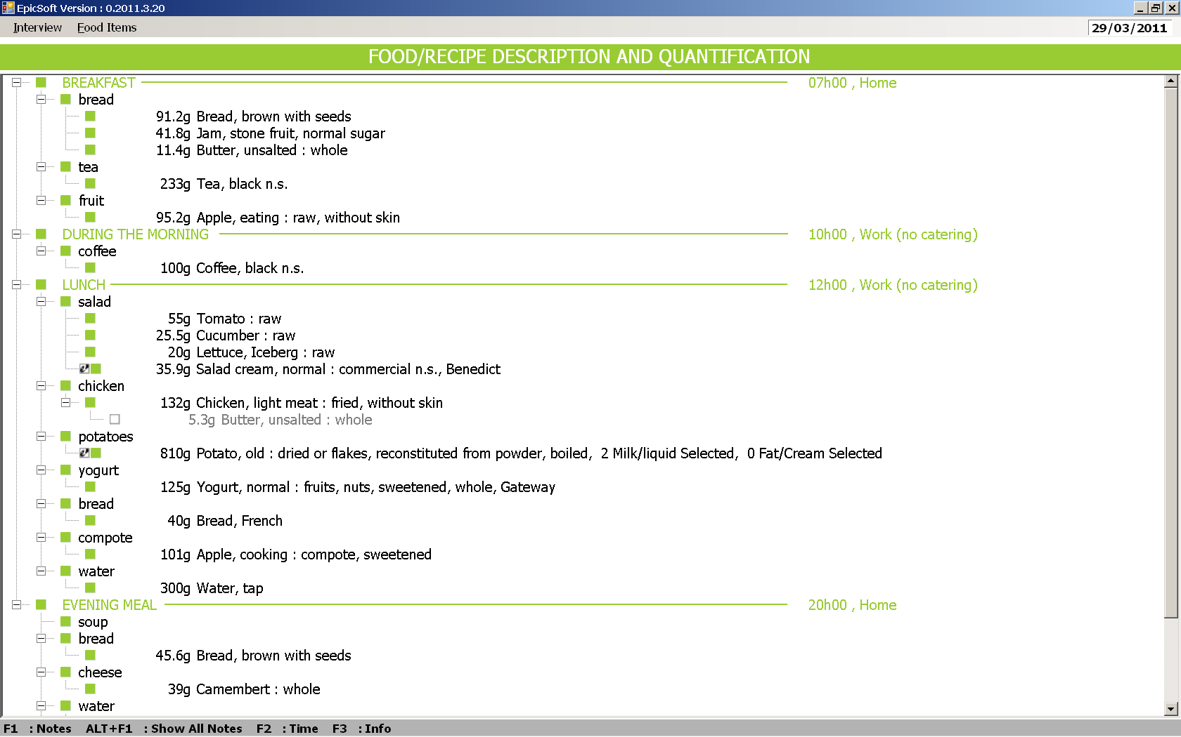

3.2 TYPE OF FOODS/RECIPES
In GloboDiet a distinction can be made between “simple foods” (and “ingredients”) and “recipes”. Depending on the type, a different procedure is followed. The border between these two types may be project-specific (e.g. soups may be considered as foods in a study and as a recipe in another study).

3.2.1 Simple foods and ingredients
Food: Food items are listed in the food list. They are either ‘simple foods’ (e.g. fruits, meat cuts, fish) or ‘complex foods’ (e.g. cakes, biscuits, dough, desserts, sauces and some snacks). Complex foods contain several ingredients but are perceived (or defined) as one food item, and are treated in the same way as simple foods. An Ingredient is attached to a recipe and is searched, described and quantified in the same way as a food.
3.2.2 Recipes
Recipe: There are two main groups of recipes, A. ‘composed recipes’ which follow the food path and the B. ‘mixed recipes’ which follow the recipe path. The mixed recipes contain three types of recipes: 1) ‘open recipes’, 2) ‘closed recipes’ and 3) ‘strictly commercial with brand recipes’.
A. Composed recipe: The different ingredients can be identified and quantified separately after preparation (e.g. rice with sauce, mixed salad) or just before mixing (e.g. coffee with milk). A composed recipe should be used even though some ingredients such as fat, sauce or sweetener cannot be quantified. GloboDiet has foreseen standard percentages for them, and standard portions (e.g. for cheese or tuna) to be used to compose a mixed salad (refer to country-specific files). Composed recipes are created during the interview. All the ingredients of the composed recipe are described and quantified separately.
B. Mixed recipe: These are recipes where, after preparation, the different ingredients cannot be identified and quantified separately. The ingredients of mixed recipes are derived from cooking books (for homemade and similar recipes), internet or are based on information received from the industry (for commercial recipes). They are entered with the RECIPE-MANAGER and handled at the country level. For each recipe, information needs to be collected if within the study population there is an expected variation of ingredients. If so, the recipe is treated as an open recipe. It is also possible to enter several recipes depending on regions. If no variations are expected, it is treated as a closed recipe or as a strictly commercial recipe. A single quantification method will be used to quantify the mixed recipe (it must be homogeneous/with constant relative ingredient proportions). Furthermore, it has to be decided if each ingredient is fixed or substitutable (see definitions below). When entering the recipe ingredients with RECIPE MANAGER, the ingredients are described and quantified following the food pathway.

Fixed ingredients are those that cannot be replaced or re-described during the interview. Substitutable ingredients are those that can be replaced or re-described during the interview. This makes the recipe more flexible, e.g. ‘oil n.s.’ to be replaced by ‘margarine, vegetable’. See the specific section 3.5.3.

3.3 GENERAL PROCEDURES

Different pathways will be followed to describe and quantify respectively “simple food” and “recipes”.

“Simple foods”, “composed recipes” and “mixed recipes” are described and quantified in the FOOD/RECIPE DESCRIPTION AND QUANTIFICATION screen, whereas the “mixed recipe” ingredient descriptions and quantifications are performed on the RECIPE INGREDIENT MANAGER screen, if applicable. The ingredients of mixed recipes are described and quantified using the same procedure as simple foods. Once finished, the final result of the mixed recipe management is reported in the FOOD/RECIPE DESCRIPTION AND QUANTIFICATION screen based on the consumed recipe portion.

3.4 SEARCH/IDENTIFICATION

3.4.1 Description of the ‘SEARCH FOR’ screen

The access to this screen is obtained by selecting one of the QUICK LIST ITEMS available in the FOOD/RECIPE DESCRIPTION AND QUANTIFICATION screen. The food and recipe lists, classified by default in alphabetical order, are displayed in the same SEARCH FOR screen but in two different windows. An automatic alphabetical search for the selected quick list item is performed in the food and recipe lists. In addition, three other alternative searches, by typing the searched name on the keyboard, by GROUP/SUB-GROUP, or SEARCH on a specific string –e.g. ‘apple’-, are possible and can be performed in the food and recipe list (one at a time).

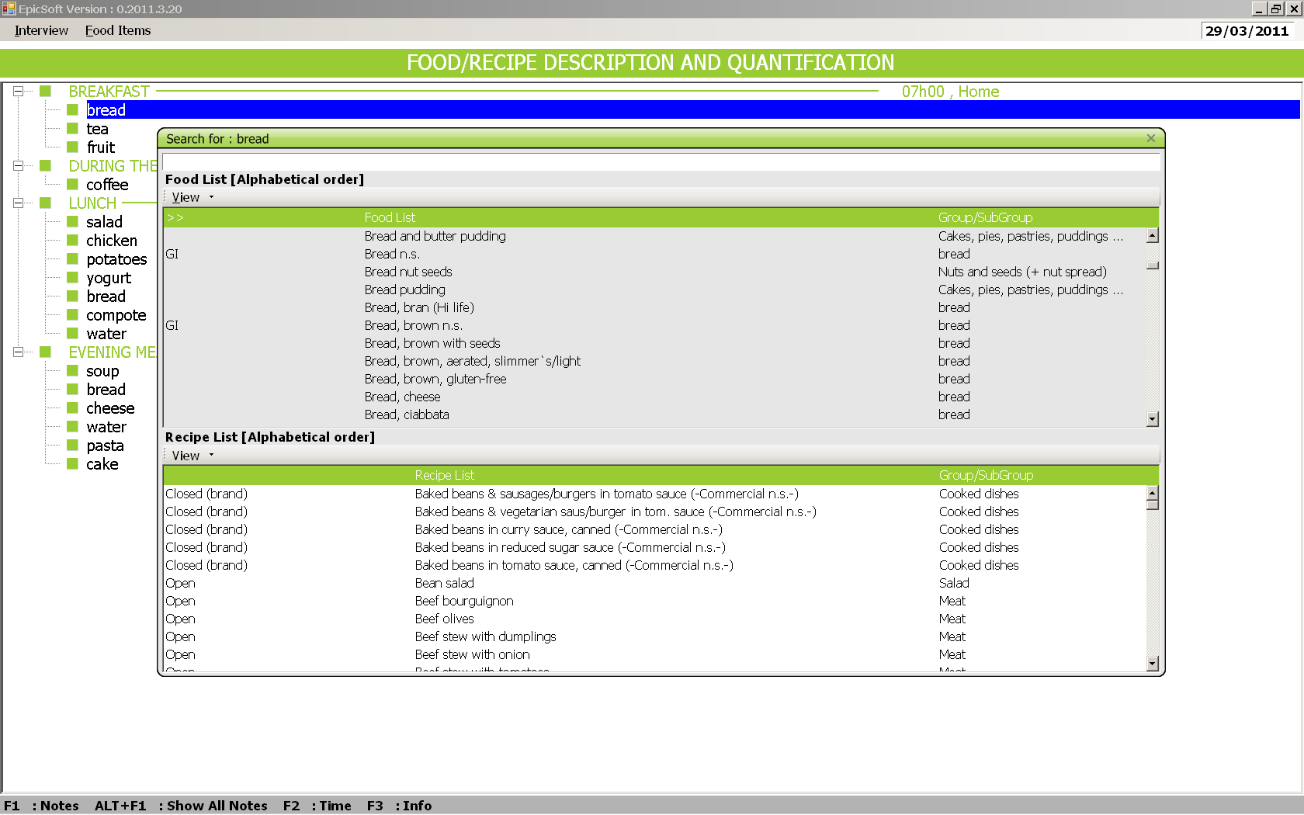

A second search on an already searched QUICK LIST ITEM can be performed by selecting it again. The previous selection will be overridden when the warning message is ignored.

3.4.2 Menus and functions available in the SEARCH FOR screen
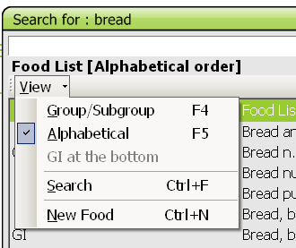

VIEW menu: This menu is the same for foods and recipes, except for the function ‘GI AT THE BOTTOM’ (Generic Items at the bottom) that is only available for the food list:

* GROUP/SUBGROUP (F4): To display the list by group/sub-group of the classification. If this option is selected, the GROUP and SUB-GROUP lists are proposed and shown in different windows on the same screen. When selecting (only) a group, all the foods/recipes in this group are displayed, if a sub-group or sub-sub-group is selected only the foods/recipes classified in that sub-group or sub-sub-group are displayed.

* ALPHABETICAL (F5): To display the food (or recipe) lists classified in alphabetical order (default).

* GI AT THE BOTTOM: When the SEARCH by food GROUP/SUB-GROUP is selected, this option enables to have the generic items (GI) reported at the bottom of the displayed list – note that on the picture above, this option is not active as ‘Alphabetical’ is ticked/selected.
Select again to de-activate (function only available for the food list).

* SEARCH (CTRL + F): This function allows a search in the food (or recipe) list for all the foods (recipes) containing a given search string, whatever its position in the name (e.g. all the food names containing the term "apple"). The search is done by default – box ‘From top’ ticked - from the top of the food (or recipe) list classified in alphabetical order, else – if the box ‘From top’ is manually unticked- the search is done from the line of the cursor downwards.
The foods (or recipes) in which the search string has been found are displayed in a separate window.
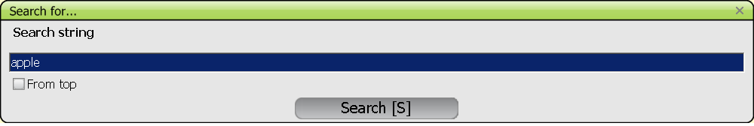

* NEW FOOD/NEW RECIPE (CTRL+N): This function can be used during the interview to add NEW foods (or NEW recipes) reported by the subject but not available in the food or recipe list. Classify the new item in its group/subgroup/sub-subgroup, and the facets and quantification methods defined for that group/subgroup/ sub-subgroup will automatically be shown. If the facet proposed by default is not relevant for describing the new food entered, the option “undefined”, available systematically for each facet, should be selected.

After quantification, the NOTES SCREEN opens automatically in order to enter any additional information that the subject may give about the new food/recipe. All new foods/recipes entered during the interview will be flagged with a black dot (see picture below). They are linked to the on-going interview only. After the interview, the coordinators will decide whether the new item needs to be added officially in the food/recipe database or not, to be available for all interviewers.
The flag 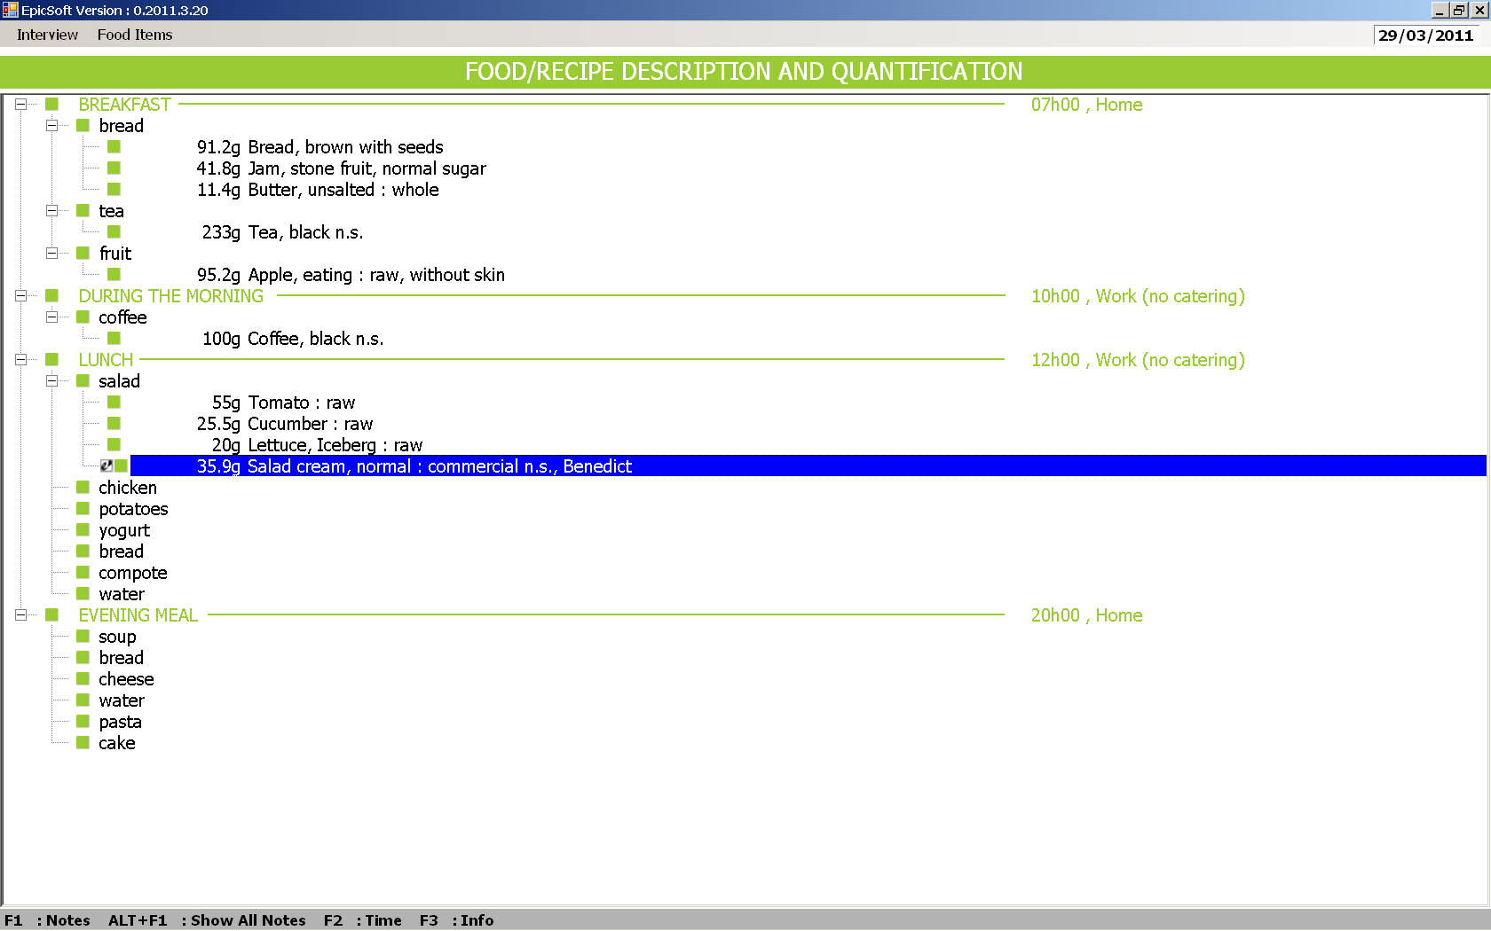 means that a note is attached to the food item.

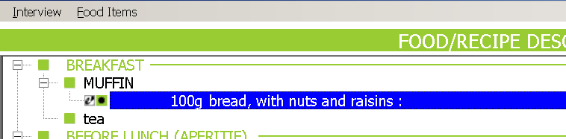

3.5 DESCRIPTION

3.5.1 Description of foods (or ingredients) and recipes

All foods and recipes attached to a given quick list item are described according to pre-defined and standardized levels of detail. The food/ingredient and recipe descriptions consist of a sequence of windows with so-called "facets", representing different characteristics of the item (e.g. cooking method, preservation method …). The series of facets correspond to the questions to be asked systematically. Each of these facets is linked to a series of "descriptors" corresponding to the potential answers which could be given by the subject (e.g. "grilled", "roasted" ... for the facet "cooking method").
Within the description step (before reaching the quantification step), it is possible to go back to a preceeding descriptor screen(s) by using the ‘Escape’ key or the upper right corner ‘x’. However the actual and previous selections will be lost: the default proposals (if any) are proposed.

3.5.2 Description with FACETS

a. Description of the FACET window
Most of the FACET windows have the same structure. The name of the facet is indicated at the top of the window with the list of possible descriptors under it. A descriptor option "undefined" (usually at the bottom of the list) is systematically available to be used if the answer is unknown. In some facets, the cursor is focused, by default, on a descriptor which corresponds to the most frequently given answer to this question (e.g. for the facet "PHYSICAL STATE/FORM AS QUANTIFIED" used to describe milk, the cursor is, by default, focused on ‘liquid’). For most of the facets, only one descriptor can be selected.
It is possible to go back to the previous facet by pressing the “Escape” button. However once you enter the quantification step of the interview, you cannot go back to the description of foods by simply pressing the “Escape” button: you have to finish the quantification step first.
You can re-describe (and then re-quantify) an item by pressing “Enter/return” button when the cursor is on that item.
In the same way, you can access the previous quantification step by pressing the “Escape” button.
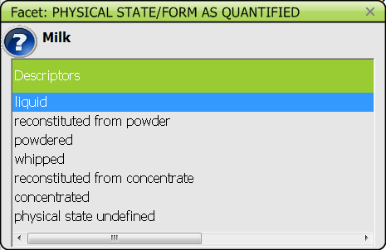

Note that some’default’ descriptors will not be shown in the item description to shorten the description.

In all the facet pop-ups, an icon “question mark”  is now available allowing to display the question to be asked by passing the mouse on it or by clicking on it. A mouse-over field pops up and provides the suggested way to formulate the question.

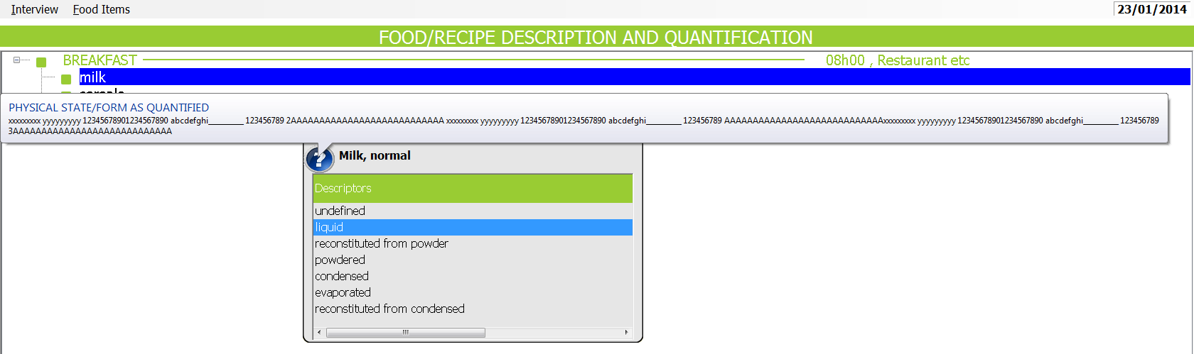

b. Particular cases
- For the facet "BRAND NAME/PRODUCT NAME", a pre-defined list of brand names (product names) may be available. However, a new brandname (product name) can be entered by selecting the descriptor "NEW" and then entering the brand name manually in the blank field "NAME" at the bottom of the pop-up.
By default, there is an alphabetical search on existing product and brand names.
You can also search for a ‘string’ in the top field as shown:

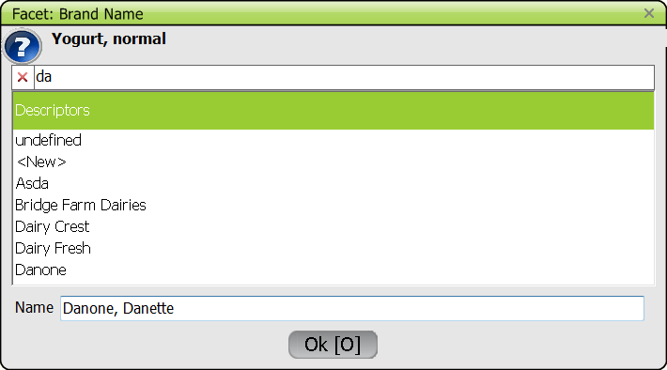

Note that the selected brand/product name is shown in the bottom field called ‘Name’ and that it may be edited to add details, e.g. ‘Danone’ may be changed into ‘Danone, Danette’.

- For some facets such as "FLAVOURED/ADDED COMPONENT", "FORTIFIED/ENRICHED" and “SOURCE”, “TYPE OF MILK/LIQUID USED”, “TYPE OF FAT USED” (see project-specific facet list), the interviewer can select more than one descriptor. The selection is made by ticking boxes with the space bar for example. The selected items are shown on the left side of the window.
The alphabetical search within the list of descriptors is available as for the brand name list.
The search on a ‘string’ is also proposed for the facets “TYPE OF MILK/LIQUID USED” and “TYPE OF FAT USED”.

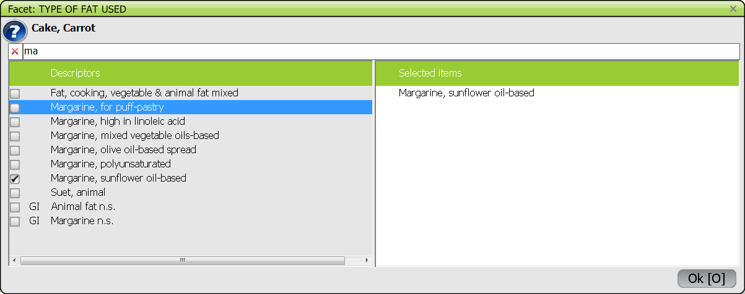

- For the facet "TYPE OF FAT USED", the descriptors proposed on the screen correspond to foods and their synonyms (SH) from the food list (chosen by the coordinators). An option “no fat used” is available at the top of the window. If the subject does not know the type of fat used, a generic item (e.g. “vegetable oil n.s”) should be selected from the food list.

- Similarly, for the facet "TYPE OF MILK/LIQUID USED", the descriptors proposed on the screen correspond to liquid foods and their synonyms (SH). Options “no milk/liquid used” and ‘milk/liquid used n.s.’ are available at the top of the window.

Note that DAIRY CREAMS could be selected in both facets and should not be counted twice.

- When selecting a descriptor ‘Other’ (identified by the coordinators), a special field ‘Other’ is displayed at the bottom of the pop-up (instead of opening the note field by F1). The entered data is stored in the Note file.
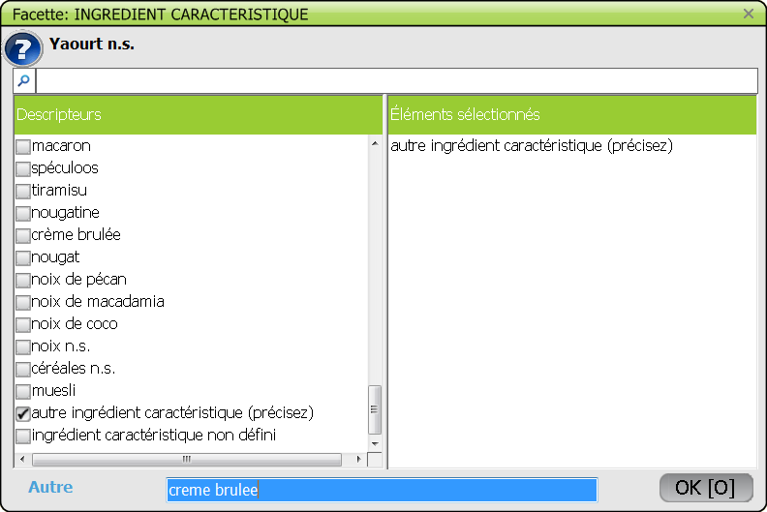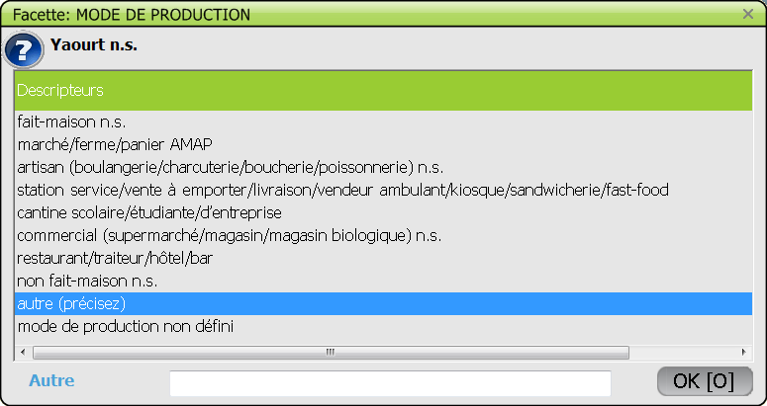

3.5.3 General information on recipes

As mentioned before, different types of recipes can be distiguished within GloboDiet (see point 3.2.2). Below more details about the procedures available for mixed recipes are given.

3.5.3.1 Mixed recipe classification

Mixed recipes are classified in a specific classification which is decided at the project level. As for foods the description and quantification of recipes will depend on their classification.

3.5.3.2. Ingredients
Ingredients may be chosen from the food and the recipe lists. ‘Sub-recipes’ are recipes used as recipe ingredients.
Note: The latter option is blocked in the first issue of GloboDiet: only foods can be selected as recipe ingredients.
- Substitutable ingredient, marked ‘SUBST’: can be replaced or re-described during the interview: All SUBST ingredients of a given recipe have to be checked with the subject.
Note that the quantity of substitutable ingredients cannot be changed.
The substitution is limited either to the group level whatever the subgroup, or to the sub-group level, or to the sub-sub-group level. No substitution is allowed for some groups/subgroups. Substitution rules are decided for each study by the coordinator .
- Fixed ingredient, marked ‘FIXED’: cannot be replaced or re-described during the interview. They will not have to be checked with the subject. All the ingredients of strictly commercial recipes are fixed.

Special rule due to ingredient description:
Some ingredients cannot be entirely re-described because of their description which has a direct link with quantification. Indeed, the descriptors ‘powdered’, ‘concentrated’, ‘dried’ and ‘semi-dried’ cannot be substituted in order to avoid quantification problems. E.g. as the quantity is fixed, 5 gram of powdered milk cannot be changed, as nutritionally, it does not correspond to 5 gram of liquid milk. The inverse is also true: liquid milk cannot be redescribed as powdered milk

3.5.3.3. Mixed recipe pathways

The mixed recipe is first described using the facet Recipe production. Two alternatives occur:
- HOMEMADE: The recipe was prepared at ‘home’. For those, no brand name will be asked.

- NOT HOMEMADE: The recipe was not prepared at home but was either produced industrially or by an artisan or prepared in a restaurant (including fast food, canteen, cafeteria, …). Thereafter the brand name of the recipe or the name of the restaurant will be captured (will depend on the coordinator’s decision).

Mixed recipes are separated into four major sets (see the schema):

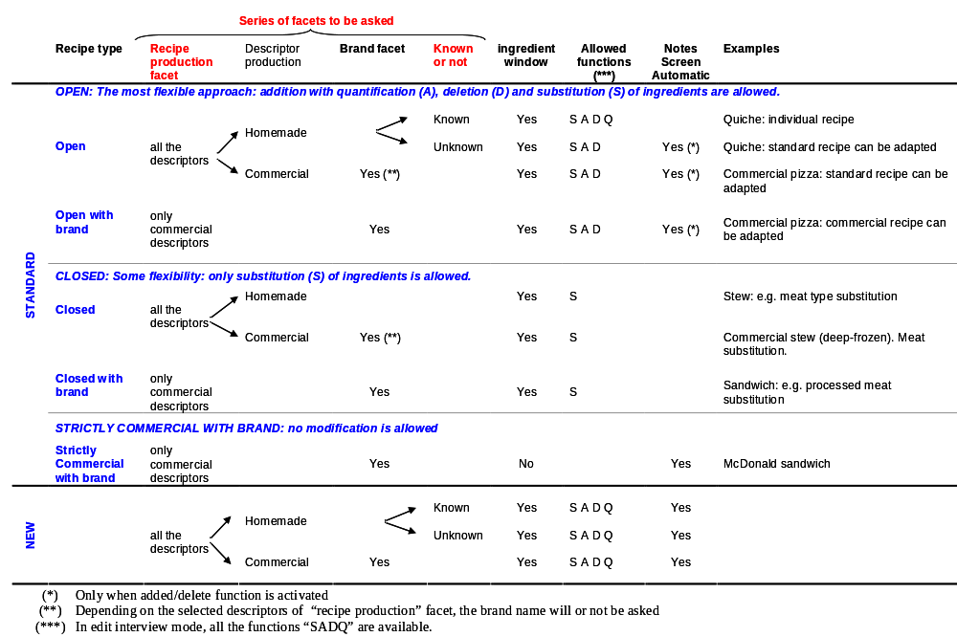

- Open recipes
This is a type of mixed recipe where it is assumed that the ingredients reported within the study population can vary considerably. A maximum of flexibility is required.
They may be with or without brand. If with brand, the commercial source (supermarket, restaurant, …) as well as the brand name of the recipe will be asked.
Within open recipes, three types of recipes exist:

1/ INDIVIDUAL RECIPE: the recipe is homemade and the subject knows the recipe (ingredients AND quantities). The participant indicates all the ingredients with their description and quantification (in the Recipe Ingredient manager screen). The pre-entered recipe ingredients are displayed as a guide, without any ingredient description, nor quantification; any ingredient can be added, deleted or substituted. When substituting, it will be possible to choose any item: type the name and it will be searched for automatically, or choose from the View menu to access an item. As a visual help, the standard recipe can be displayed with the % as estimated and as consumed.
2/ ADAPTABLE RECIPES:
2a/ The recipe was prepared at home and the subject does not know the recipe. After the description and quantification of the consumed portion of the recipe, the standard recipe is proposed (in the Recipe Ingredient manager screen), the ingredient quantities are based on the consumed portion of the recipe and it is possible to substitute ingredients flagged as SUBST and if not sufficient add (relative to the consumed portion) or delete some. Depending on the amounts added and/or deleted in the Recipe Ingredient manager (definition of a cut-off percentage at the project level), the changes may or may not be readily taken into account on the description/quantification screen and the addition and/or deletion of ingredients may or may not have to be checked/validated after the interview (in EDIT interview mode). To keep the integrity of the original recipe, some limitations have been implemented (see 3.9).
2b/ The recipe is commercial. The subject is not asked if the recipe is known. The recipe brand name is to be indicated. After the description and quantification of the recipe, the standard recipe is proposed (in the Recipe Ingredient manager screen), the ingredient quantities are based on the consumed portion of the recipe and it is possible to substitute ingredients flagged as SUBST and if not sufficient add (relative to the consumed portion) or delete some. Depending on the amounts added and/or deleted in the Recipe Ingredient manager window (definition of a cut-off percentage at the project level), the changes will be readily taken into account or not on the description/quantification screen and the addition and/or deletion of ingredients will have to be checked/validated after the interview (in EDIT interview mode) or not.
In both cases, the original standard recipe can be displayed (with the % as estimated and as consumed) as a visual help. The NOTE file is prompted automatically when saving the recipe in case of added and/or deleted ingredient; comments may be added to the automatic notes.
- Closed recipes
This is a type of mixed recipe where it is assumed that the ingredients reported within the study population do not vary, especially in their relative quantity. Therefore, the subject is never asked if he/she can identify, describe and quantify all the ingredients before preparation; only substitutions are allowed.
They may be with or without brand. If without brand, the recipe may be homemade or commercial. In the latter case, the brand name of the recipe will be asked. If with brand, the commercial source (supermarket, restaurant, …) as well as the brand name of the recipe will be asked.
The pre-entered recipe is treated as a standard (in the Recipe Ingredient manager) where the ingredients appear with their description and quantification (based on the consumed portion of the recipe). The subject is asked if the substitutable ingredients should be replaced or re-described. However, quantities cannot be changed, and no ingredient can be deleted or added (this can only be mentioned in the NOTE file). Fixed ingredients can neither be re-described, substituted, nor re-quantified. No ingredient can be added or deleted to the standard recipe: this can only be described in the NOTE file by pressing F1.
- Strictly commercial recipes
They are always with brand: the commercial source (supermarket, restaurant, …) as well as the brand name of the recipe will be asked. No ingredient check is performed during the interview as all ingredients are fixed. The NOTE file is prompted automatically.
- New recipes
These are recipes which are not available in the recipe list. It will be possible to record them during the interview.
If the subject knows the recipe, all the ingredients will be described and quantified in the Recipe Ingredient manager. In case the recipe is unknown, the Recipe Ingredient manager will also be proposed to enter a maximum of information. In any case, the NOTE screen is proposed to enter extra information. The validation of the new recipes will be done outside the interview (in EDIT interview mode). New recipes remain linked to the on-going interview only.

3.6 QUANTIFICATION

3.6.1 Quantification of simple foods (or ingredients of composed recipe)

Simple foods or ingredients of composed recipes are always quantified "as consumed" with one of their pre-defined quantification methods.

3.6.2 Quantification of mixed recipes and their ingredients

A mixed recipe and its ingredients are quantified in three main steps:

1. Quantification of the mixed recipe portion actually consumed by the subject: The estimated quantity refers to the "as consumed" weight of the portion (i.e. the weight of the prepared portion actually consumed by the subject). The methods of quantification are pre-defined for each standard recipe. In the case of a new recipe entered during the interview, the quantification methods which appear are defaults defined for the group into which the new recipe has been classified.

2. Quantification of each ingredient of the mixed recipe:
For ‘open recipes’, if the subject knows the recipe, the ingredients are quantified “as estimated”, as they were before preparation (mainly raw with inedible part), with one of the pre-defined quantification methods for the food (an ingredient is treated as a simple food). If the subject does not know the quantities of each recipe ingredient the standard quantities of ingredients are taken. Added ingredients have to be quantified based on the consumed quantity of the mixed recipe.
For ‘closed recipes’ and ‘strictly commercial recipes’, the subject is not asked whether he/she knows the recipe and standard quantities of ingredients are taken.

3. Automatic calculation of the weight of each ingredient of the recipe portion actually consumed by the subject.

3.6.3 Quantification methods available (and related screens)

Different methods are available for food and recipe quantifications. At the time of quantification, the specific methods that can be used are presented in the QUANTIFICATION METHODS screen.
It is noteworthy that for all quantification methods, fractions can be specified and the option “other fraction” can be chosen to specify a fraction which is not available in the predefined list.

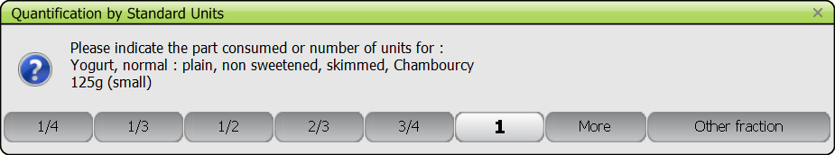

If the chosen quantity exceeds the pre-defined ‘maximum value’, a warning pops up and the interviewer has to check with the participant the entered value is correct; else another quantity can be entered.

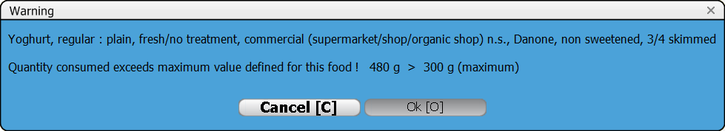

During the quantification of an item, if the selected method does not suit, you can access the previous quantification step to choose another method by pressing the “Escape” button.

WEIGHT method and VOLUME method

These methods, which are systematically available for all foods and recipes, can be used when the subject knows the quantity of the food consumed in grams or in milliliters (or Imperial units, if the option has been selected from the SETUP option in the 24-HOUR RECALL menu). The quantity is entered manually. If relevant, questions are asked on whether the estimated quantity entered is “raw” (raw-to-cooked calculation needed) or “cooked” (no raw-to-cooked calculation needed) and/or with or without its inedible part (edible part coefficient needed or not).

PHOTO method

For certain foods, pictures with different portion sizes are available in the “GloboDiet PICTURE BOOK (or study-specific photo booklet) for estimation of food portion sizes” (see Appendix 5). The selection of the series of pictures to be used is based on the ‘comment’ behind the code of the series.

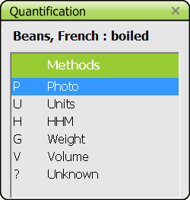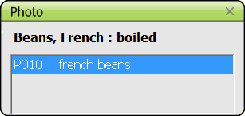

Once a series is selected, the QUANTIFICATION BY PHOTO window opens indicating the code and name of the series and the codes of each picture with the weight corresponding to the portions. The series should be looked up in the book using the code (and page number) and the subject should select the portion. Select the corresponding code then indicate whether the whole portion size or only a fraction of it was consumed and whether another serving from the same photo series has been consumed or not.

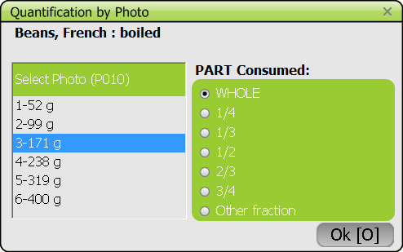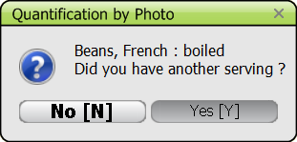

SHAPE method

For certain food groups (e.g. bread, cakes, etc…) predefined shapes/surfaces can be used to quantify the particular food or recipe item. For these food items, an additional question is asked about the thickness of this food item (to be selected from a predefined list) to calculate the weight consumed for that particular food item.
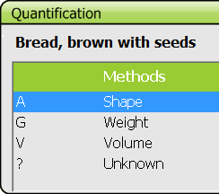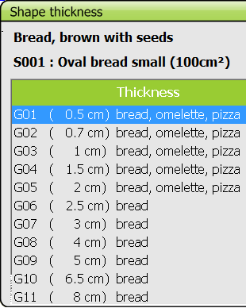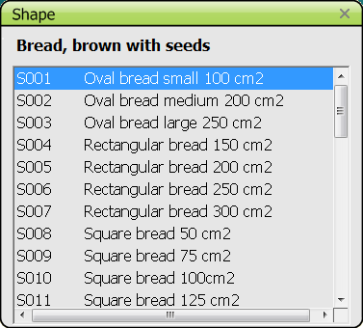

For toppings (e.g. jam spread on bread) a shape/surface must be selected together with the thickness of the topping estimated using a photo series (e.g. the photo series presenting different thicknesses of jam spread on bread) in order to calculate the weight of the topping that was consumed.

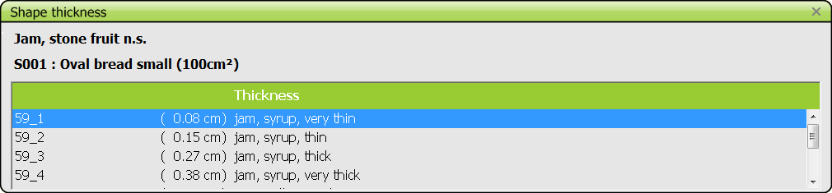

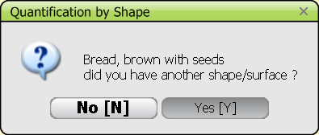
During the interview, you may choose different shapes for a given food item, under the same quick list item:

STANDARD UNIT method

Standard units (STDU) are used for foods that exist in distinguishable units with more or less standard weights (e.g. apples, packages). There may be more than one STDU proposed for the same food and, if so, these can be identified by ‘comments’ in the STDU SELECTION window. Select the standard unit method (identified with U), and select in the STDU SELECTION window the STDU corresponding to the description of the subject. A ruler might be needed to discriminate between units.

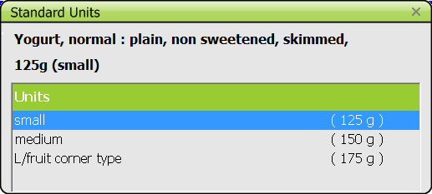

The next window proposes predefined fractions of the STDU and the options MORE and OTHER FRACTION. If MORE is selected, the number of the STDU can be indicated (e.g. 2.5 cubes of sugar). An alternative is to use OTHER FRACTION where two numbers must be entered (e.g. 5/2 for 2.5 cubes of sugar).
In case of new food/recipe, as no pre-defined standard unit exists, a window asks to enter an approximative weight in grams. This will have to be re-entered in EDIT interview mode.

HOUSEHOLD MEASURE method

Household measures are used to estimate the volume of portions. When the household measure method is selected (indicated with H), the HOUSEHOLD MEASURES window opens with the entire country-specific list of HHM and their volumes. The HHMs are identified by a code corresponding to the number indicated on the household measures available during the interview or on the picture of the measures. Select the HHM from the list using the ruler. For a quick access, directly type the first digit of the code of the measure. The next window proposes predefined fractions of the HHM and the options MORE and OTHER FRACTION. If MORE is selected, the number and the corresponding fraction of the HHM can be indicated (e.g. two glasses of cognac: 2 x 1/3). If relevant for the food, questions are asked on whether the estimated quantity is raw or cooked and/or with or without its inedible part.

STANDARD PORTION method –for foods only

This method, indicated with STDP, can be used when the food is identified but cannot be quantified (e.g. melted cheese on a dish). In this case a standard quantity is applied. When selecting the STDP, a comment indicates what the standard quantity refers to. No fraction can be selected.

UNKNOWN method

This option can be used when the subject cannot estimate the quantity consumed or the standard to be applied. In this case a question mark (?) is reported for the quantity and an automatic note is generated by the system. For any additional remarks, go to the notes screen (F1).
For fats, sauces and sweeteners which are part of a composed recipe or added on a mixed recipe, the system calculates a quantity which replaces the unknown quantity (see the paragraph 3.6.4).

Portion of whole known recipe (NEW quantification method)

This option is only proposed for known recipes, i.e. the participant can report all the ingredients and their quantities. The consumed quantity can be entered as a fraction of the described recipe.

3.6.4 Automatic calculations of standard quantity of fat, sauce or sweetener

1/ For all fats used during cooking a “simple food”, the quantity absorbed by the food is automatically calculated, once a cooking method that uses fat is selected (see definition of the facet “cooking method” in appendix 1). Only the qualitative type of fat used for cooking is asked, and several fats can be selected. If a mixture of fats is used for cooking, the standard percentage of fat applied to a given food is divided by the number of fats selected (e.g. if 15% of fat absorption is applied for fried potatoes and two fats are used for frying, 7.5% is applied to each fat selected). The type and the standard quantities of cooking fat(s) attached to a given food cannot be deleted (or modified) directly from the food and recipe description and quantification screen. This can be done only by re-describing and/or re-quantifying the main food (e.g. changing the cooking method descriptor, the food portion consumed or/and the qualitative type of fat(s) used for cooking). Subsequently the standard percentage of fat used and/or the final fat quantity obtained are changed.
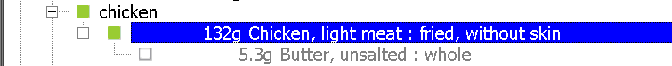
For standard recipes entered beforehand, or for individual recipes reported by the subject during the interview, only the fat used for deep fried foods will automatically be calculated. So fats used within the recipes must be treated as ingredients.

2/ For fats, sauces and sweeteners that are added to the food or mixed recipe before eating (e.g. after cooking) and for which the quantification method “unknown” is selected, a calculation of the quantity takes place once the quicklist item or mixed recipe is finished. A screen containing the complete list of ingredients attached to the quick list is displayed (“fat/sauce/sweetener association table”), and the interviewer has to select, using the spacebar (or the mouse), the ingredients on which fat (sauce, or sweetener) have been added and confirm by OK.
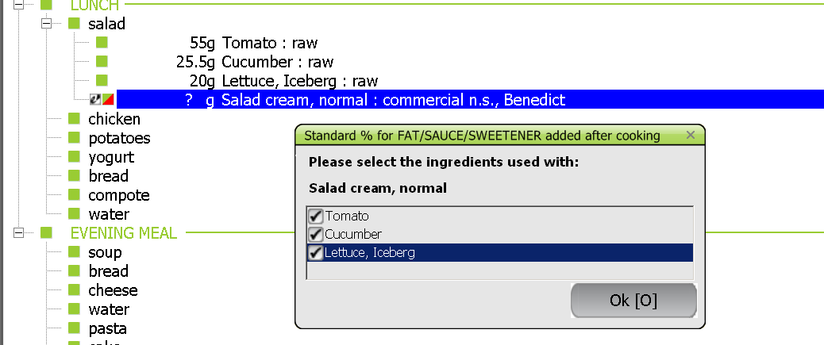
If several fats (added after cooking), sauces or sweeteners of the same quick list item are reported with missing quantities, the “fat/sauce/sweetener association table” is proposed as often as the number of missing quantities of fats (sauces or sweeteners) reported. The standard percentage used for a given food is then divided by the number of fats (sauce, or sweetener) added to that particular food (e.g. if olive oil and sunflower oil are used for a mixed salad, and 10% of fat is applied as a standard on the raw tomato portion, this standard is divided by two: 5% of olive oil and 5% of sunflower).

- Fats are foods in food group 10 Fats and sub-group 05 07 Creams,
- Sauces are the savoury sauces classified in sub-group 15 01 Sauces and the sweet sauces classified in 11 01 05 Sweet sauces/toppings and 11 02 00 Chocolate sauce,
- Sweeteners are foods classified in 11 01 00 to 11 01 04 and 11 01 06: Sugar, jam, honey, spread, syrup and 11 02 03 Chocolate spread and powder.

3.7 CHECK FOR MISSING INGREDIENTS

This control by probing questions is made systematically to check the completeness of the item list
- reported under the quick list items or
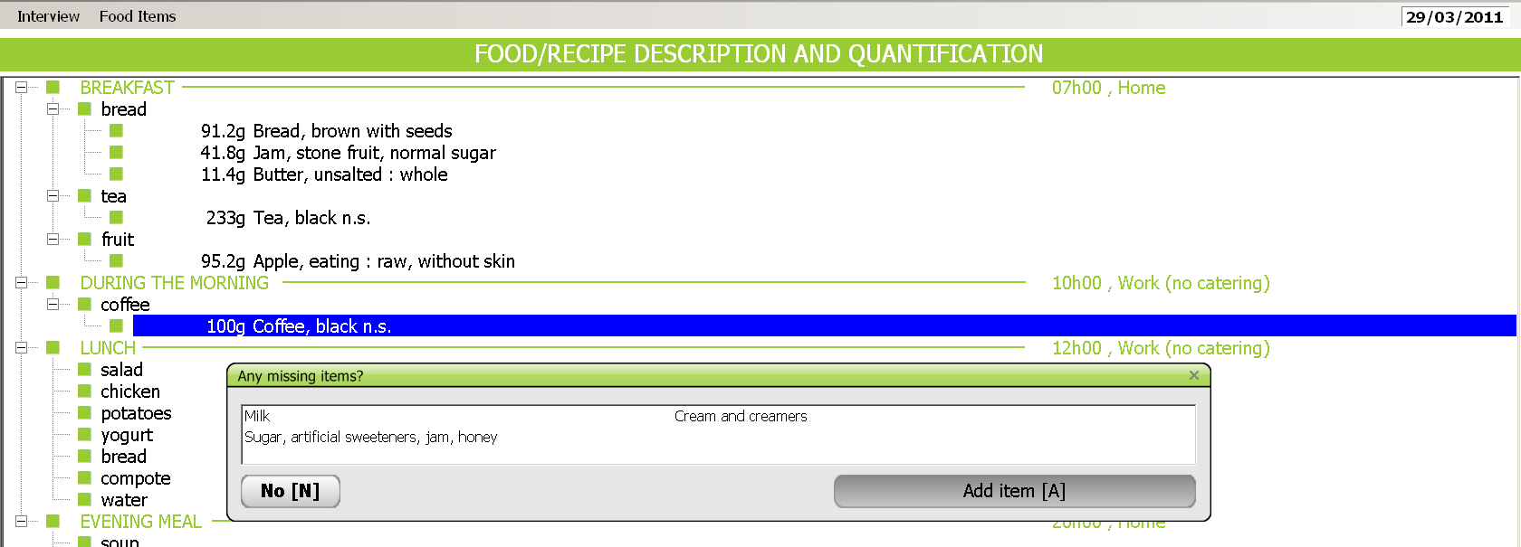
- linked to the individual mixed recipes.

After having described and quantified a food and after having saved a mixed recipe, the question “Any other item to be added to the quicklist item?” is proposed. After a negative answer, a window ‘Any missing items?’ opens with a list of easily forgotten foods in relation to the ingredients (foods) reported under the quicklist item or to the mixed recipe. After checking with the subject if any ingredient is missing, two options are available:

* NO: to leave the “Any missing items?” window and return to the FOOD/RECIPE DESCRIPTION AND QUANTIFICATION screen

* ADD ITEM: to go directly into the SEARCH FOR screen to select and add the missing item(s).

N.B.: If only one food is reported in the list of items (simple food) the missing items to be checked are specific to this food. However, if several items are reported for a given composed recipe or mixed recipe, the missing items are the sum of the specific items linked to each food, without duplication of those that are common.

3.8 MENUS AND FUNCTIONS AVAILABLE IN THE FOOD/RECIPE DESCRIPTION AND QUANTIFICATION screen

INTERVIEW menu

* ALL OCCASIONS/SELECT OCCASION: To display either all FCOs on the screen (default) or select successively each FCO.

* RECIPE INGREDIENTS (F7): By default, only the name and the portion of mixed recipes are indicated on the FOOD/RECIPE DESCRIPTION AND QUANTIFICATION screen. Use this function to display also the ingredients and their corresponding description (descriptors) and weights.

* QUICK LIST (F9): Function allowing a switch from the FOOD/RECIPE DESCRIPTION AND QUANTIFICATION screen to the QUICK LIST screen (and vice versa)

* NEXT INTERVIEW STEP: Option allowing the interview to proceed

FOOD ITEMS menu

* ADD ITEM (F4): Option allowing ingredients to be added. The added food or recipe is inserted at the place where the cursor is focused. After selection of the function, the SEARCH FOR screen opens and the food/recipe can be selected from the list (see description of SEARCH SCREEN in 3.4)

* DELETE ITEM (F6): Function allowing a food/recipe attached to a quicklist item to be deleted.

* UNDELETE ITEM (SHIFT + DEL): Function allowing listing all the items which have been deleted during the interview. To undelete an item, set the cursor on this item and select ‘OK’. The cursor will be set on the undeleted item in the FOOD/RECIPE DESCRIPTION AND QUANTIFICATION screen. ‘Cancel’ enables to leave this window without modification.

* MODIFY QUANTITY (F10): Function allowing the modification of the quantity reported for foods or mixed recipes already described and quantified without having to describe again (for example after having copied an item).

* EDIT MIXED RECIPE (F8): Function allowing a switch from the FOOD/RECIPE DESCRIPTION AND QUANTIFICATION screen to the RECIPE INGREDIENT MANAGER screen to complete information regarding the mixed recipe ingredients. This function is active only if the cursor is focused on a mixed recipe (indicated in brackets { } and blue square).

* EXPAND/COMPRESS INFO (F11): Function to open (and close) a window with detailed information on the item that the cursor is focused on. Information is given on the method of quantification, the estimated quantity, the finally consumed quantity with the calculation (including raw to cooked, edible part and density factors) and the descriptors selected for the food (only those displayed in the main screen).

* PROBING QUESTIONS (F12): Function to display the checklist for missing ingredients, concerning the quick list item on which the cursor is focused (see section 3.7).

* COPY ITEM TO (F5): Function to copy an already described and quantified food, recipe or quicklist item under another not yet finished quicklist item. Select by a RETURN or with the mouse, the QLI, food or recipe to be copied. A screen containing all the FCOs and their corresponding quick list items is displayed. Select from this screen by a RETURN the QLI under which the copy should be made.
Note that it is wise to check the quantity of the copied item(s).

* FAT/SAUCE/SWEETENER ADDED: Function to display the screen “fat/sauce/sweetener
association table” containing the ingredients attached to a given quick list item. The list of ingredients on which standard percentages of fat (sugar, or sweetener) have been applied can be modified.

3.9 MENUS AND FUNCTIONS AVAILABLE IN THE RECIPE INGREDIENT MANAGER screen(s) (to be used specifically for mixed recipes)

* In the INDIVIDUAL RECIPE screen (displayed only for individual recipes entered with the option NEW RECIPE):

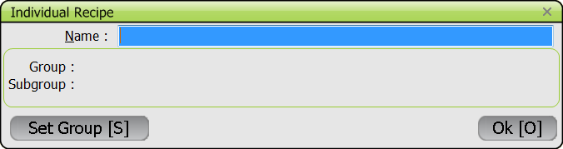

* NAME field: Enter manually the name of the NEW mixed recipe.

* SET GROUP: Function to complete the GROUP/SUB-GROUP fields. Two windows open: on the left side the list of groups, on the right side the list of subgroups if available. Move from one window to another with TAB and select the (sub)group.

* In the RECIPE INGREDIENT MANAGER screen:

For open and new recipes, the following functions are available in the INGREDIENTS menu. Some of them are only available when the recipe is known by the subject (individual recipe).

* ADD INGREDIENT (F4): Option allowing ingredients to be added. The added food is inserted under the ingredient the cursor is focused on. After selection of the function, the SEARCH FOR screen opens and the food can be selected from the list (see description SEARCH screen).
For unknown open recipes, the quantity must be relative to the consumed portion, not to the whole recipe (enter a Note in this case), and entered “as consumed”.
For new recipes or known open recipes, the quantity is for the whole recipe, and entered “as estimated”.
All the changes of quantity above a certain cut-off point will have to be validated in EDIT interview mode and the related ingredients will not be listed in the FOOD/RECIPE DESCRIPTION AND QUANTIFICATION screen (see Note below). Only the ingredients with a quantity below the cut-off point will be taken into account in the FOOD/RECIPE DESCRIPTION AND QUANTIFICATION screen.
Note: The quantities of added and deleted ingredients are summed up, translated as a percentage of the total consumed portion and compared to the set cut-off point (usually 5%).
In the example of the ‘Soup, vegetables, with leek…’ recipe below the deleted ingredient (onion) forms a proportion of the recipe above the set cut-off (5% here) and therefore it is not removed from the ingredient list and only striked through in the RECIPE INGREDIENT MANAGER screen. On the other hand, the added ingredient (courgette) also has a quantity above the 5% cut-off. It is only listed in the RECIPE INGREDIENT MANAGER screen but its consumed quantity (in % and g) appears as missing. In the FOOD/RECIPE DESCRIPTION AND QUANTIFICATION screen, the deleted item above the cut-off point is listed and striked through, the added item above the cut-off point is not listed. For the final quality check, the ingredients “above the cut-off point” are not taken into account as the recipe is not considered as valid. The overall recipe is flagged with a red sign and needs to be checked by the study coordinators along with the automatically generated note (see section V). Interviewer can provide additional information in the Note regarding the added/deleted ingredient(s) to help the coordinator when updating the recipe.
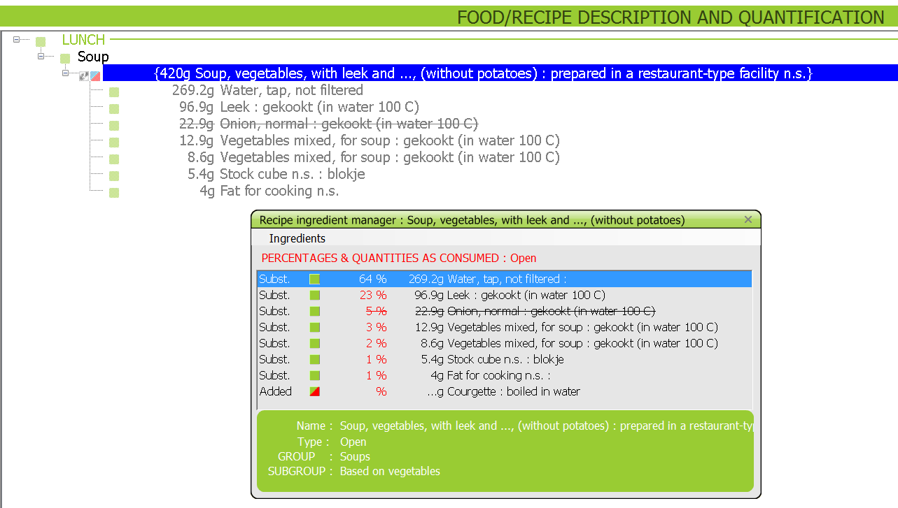

A warning appears if the sum of added ingredient quantities is too high, i.e. it represents e,g, more than 50% - set by the coordinators- of the consumed recipe quantity. The interviewer has to confirm by clicking on Yes, or modify the new quantities of the added ingredients after clicking on No.

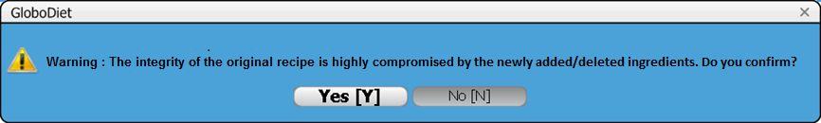

The same warning appears if the sum of deleted ingredients quantities is too high. The interviewer has to confirm by clicking on Yes, or modify the new quantities of the added ingredients after clicking on No.

If the added ingredient quantity is above the consumed quantity of the whole recipe, the following error message appears. The user is forced to re-enter a new quantity for the added ingredient.
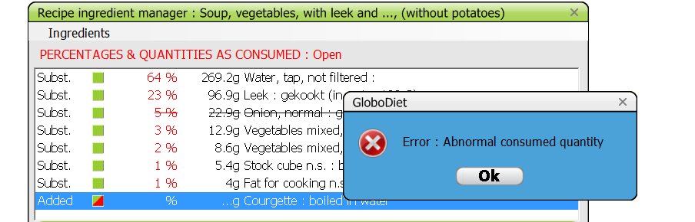
When saving the recipe, if the sum of the added ingredient quantities is equal to or greater than the consumed recipe quantity, an error message will appear. The interviewer has to review the quantities of the added ingredients.
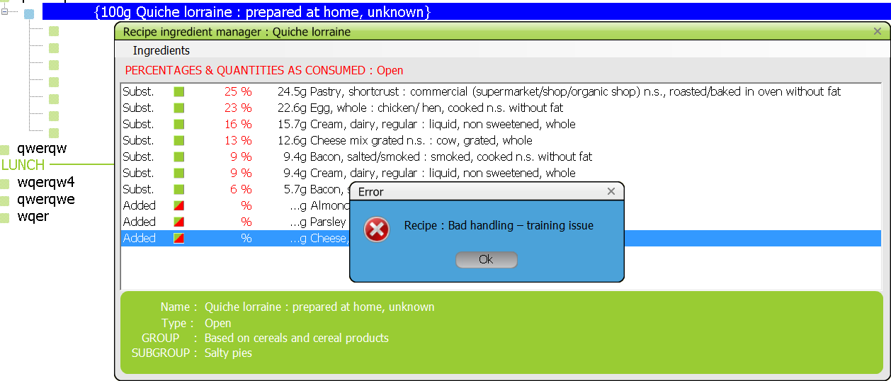

* DELETE INGREDIENT (F6): Function allowing an ingredient to be deleted. See remarks listed under ADD INGREDIENT (F4).

* UNDELETE ITEM (SHIFT + DEL): Function allowing listing all the items which have been deleted. To undelete an item (which is striked through), set the cursor on this item and select ‘OK’. ‘Cancel’ enables to leave this window without modification.
Note that if the recipe has been saved and the deletion accepted, the deleted item will not appear striked through any more when you edit the recipe with F8, so it cannot be retrieved by the function UNDELETE ITEM.

* MODIFY QUANTITY (F10) (only if known or new recipe): The quantity of ingredients already described and quantified, can be modified with this function without having to re-describe again. Note that this quantity is “as estimated” and for the whole recipe.

* SUBSTITUTE: This option is active on a substitutable ingredient (identified by the prefix SUBST.) on which the cursor is focused, allowing the food to be substituted by another food as described in 3.5.3. An alternative is to press the “enter/return” button.
Note: This function should be preferred to adding/deleting ingredients whenever possible (e.g. ingredients within the same food (sub)group).

* DESCRIBE: Option allowing going into the description of a substitutable ingredient and updating it. An alternative is to press the “enter/return” button.

* PROBING QUESTIONS (F12) (only if known or new recipe): Function to display the checklist for missing ingredients attached to the recipe ingredient.

* RECIPE GROUP/SUB-GROUP (only if known or new recipe): Option allowing the modification of the group/sub-group and the name of the mixed recipe actually displayed.

* HELP RECIPE: Function to display a standard recipe chosen from the recipe list in a separate window.

* SAVE RECIPE AND EXIT (F9): Option to save and exit

* QUIT (ALT F4): Exit without saving, so the recipe is cancelled.

For closed recipes selected from the recipe list, only the four following options are available in the INGREDIENTS menu:

* SUBSTITUTE: This option is active on a substitutable ingredient (identified by the prefix SUBST.) on which the cursor is focused, allowing the food to be substituted by another food as described in 3.5.3. An alternative is to press the “enter/return” button.

* DESCRIBE: Option allowing going into the description of a substitutable ingredient and updating it. An alternative is to press the “enter/return” button.

* EXIT AND SAVE (F9): Option to save and exit

* QUIT (ALT F4): Exit without saving, so the recipe is cancelled.

3.10 SUMMARY OF THE PROCEDURE FOR COMPLETING THE FOOD/RECIPE DESCRIPTION AND QUANTIFICATION

- Select a quicklist item to run the automatic SEARCH

- Select a food or a mixed recipe from the corresponding lists or, if no match can be found, create a new food or recipe

3.10.1. If the item corresponds to a simple food or to an ingredient of a composed recipe:

- Select the food from the list. In case the food cannot be found in the food list, enter it as New food in the Search for/View menu: define its name and classification and enter additional information in a note field at the end of this step. Notes can also be entered by pressing F1 and “specific notes” for regular items.

- Describe the food (with proposed facets/descriptors)

- Quantify the food with one of the pre-defined methods

- Add another ingredient to the QLI if needed

- End the description and quantification of the quick list item by answering NO to the question “add another ingredient?”

- Check for any missing ingredients

- End

3.10.2. If the item found or selected during the search corresponds to a mixed recipe:

- Select the mixed recipe from the recipe list. In case the recipe cannot be found in the recipe list, enter it as New recipe in the Search for/View menu: define its name and classification and enter additional information in a note field at the end of this step. Notes can also be entered by pressing F1 and “specific notes” for regular items.
- For existing recipes, confirm the recipe selected after checking its information, or cancel to select another recipe
- Describe the recipe (with proposed facets/descriptors)

1. Open recipes. (The prefix "Open" is indicated in front of the recipe name):

* If the recipe is of homemade-type, the facet ‘Known/Unknown’ is proposed

* If the answer is Unknown:

- Quantify the recipe portion consumed by the subject with one of the pre-defined quantification methods. This portion will be used as basis to check the recipe ingredient (next step)
- The RECIPE INGREDIENT MANAGER screen is then displayed. Substitute/re-describe the ingredients identified by the prefix “SUBST” and Add/Delete ingredients, if needed. The quantities of the added ingredients are related to the subject portion, not to the initial recipe that the subject does not know

- EXIT and SAVE the mixed recipe when the modifications are completed
- Answer to the question “Any other item to be added to the quicklist item?” If the answer is ‘no’ the MISSING INGREDIENT screen to be applied to the whole recipe is displayed. Add another food or exit

* If the answer is Known:

- Quantify the recipe portion consumed by the subject with one of the pre-defined quantification methods
- The RECIPE INGREDIENT MANAGER screen is displayed. Enter the individual recipe reported by the subject by describing and quantifying each ingredient. The recipe name and classification may be changed. A Help recipe may be chosen from the recipe list.
- EXIT and SAVE the mixed recipe when completed
- Answer to the question “Any other item to be added to the quicklist item?” If the answer is ‘no’ the MISSING INGREDIENT screen to be applied to the whole recipe is displayed. Add another food or exit.

* If the recipe is of commercial-type:

- Report the brandname/product name of the recipe consumed (select “commercial n.s” if not known by the subject or “New” if not listed)
- Then proceed as for unknown homemade-type recipes.

2. Closed recipes (The prefix "Closed" is indicated in front of the recipe name):

* If the recipe is of commercial-type:

- Report the brandname/product name of the recipe consumed (select “commercial n.s” if not known by the subject or “New” if not listed)

* Then in all cases,

- Quantify the recipe portion consumed by the subject with one of the pre-defined quantification methods
- The RECIPE INGREDIENT MANAGER screen is then displayed. Substitute/re-describe the ingredients identified by the prefix “SUBST”, if needed.
- EXIT and SAVE the mixed recipe when completed
- Answer to the question “Any other item to be added to the quicklist item?” If the answer is ‘no’ the MISSING INGREDIENT screen to be applied to the whole recipe is displayed. Add another food or exit.

3. Strictly commercial recipes (The prefix "Strictly commercial" is indicated in front of the recipe name):

- Report the brandname/product name of the recipe consumed (select “commercial n.s” if not known by the subject or “New” if not listed)
- Quantify the recipe portion consumed by the subject with one of the pre-defined quantification methods
- Enter notes in the Note screen which is automatically proposed, if needed
- Answer to the question “Any other item to be added to the quicklist item?” If the answer is ‘no’ the MISSING INGREDIENT screen to be applied to the whole recipe is displayed. Add another food or exit.

When the description and quantification step is finished, select NEXT INTERVIEW STEP in the INTERVIEW menu.

- QUALITY CONTROLS

Different quality controls are made on the data collected or entered at the different stages of the dietary interview procedure. These are just warnings or helps for the interviewers. Data entered have to be either confirmed or changed.
- Controls on out-of-range values in the general information screens – Chapter IV.1 (e.g. date of birth, weight, height);
- Controls on easily forgotten foods attached to a given food consumption occasion, based on the check list mentioned in Chapter IV.2.2;
- Controls on empty food consumption occasions (see chapter IV.2.2.);
- Controls on out-of-range values during the quantification of foods and recipes – Chapter IV. 3.6.3;
- Controls on out-of-range values during the quantification of ingredients – Chapter IV. 3.9
- Controls on easily forgotten foods attached to a given quick list item or recipe, based on the probing questions, mentioned in Chapter IV.3.7;
- Controls on unknown and overflow quantities which are automatically captured in notes by the system during the interview. Before ending the interview, the UNKNOWN AND OVERFLOW QUANTITY SUMMARY screen listing the empty QLI and foods/recipes with missing (or overflow) quantities is displayed. This concerns all the reported foods/recipes for which the UNKNOWN quantification method has been used, those with quantity equal to zero and those exceeding the maxima values.

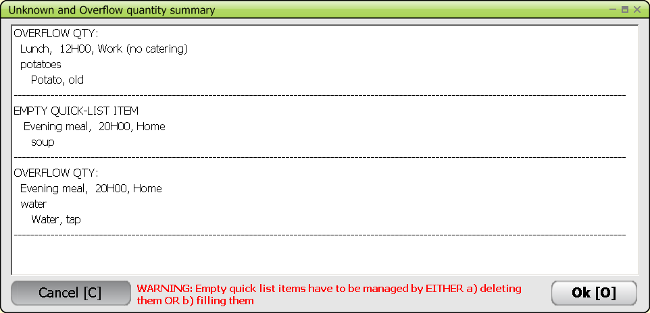

Empty QLI should be removed before going to the following step: choose Cancel and either delete them or add item(s) under them.
- Controls at the nutrient level. This last quality control of the dietary interview compares the estimated energy and macro-nutrient intakes with standard requirements calculated for the age and sex of the subject. The DIETARY INTERVIEW SUMMARY AND FINAL CHECKS screen displays general information on the subject (sex, age, weight, …) and the calculated energy requirement. Therefore the interviewer will visually check that the calculated energy requirement is compatible with the reported intake.The estimated energy and macro-nutrients (in grams and percentage of the energy intake) are reported at the top of the table. If energy or one of the macro-nutrient values (proteins, fats, carbohydrates, alcohol) estimated from the 24-hour recall is out of the expected ranges, a warning TOO LOW or TOO HIGH is displayed. The energy intake and the corresponding "as consumed" weights of foods and ingredients are reported in four main categories (breakfast, lunch, dinner and other, plus total) to check whether an error can explain out of range intake value. Overflow quantities are written in red in the detailed and compressed lists to ease the visual control. These lists are accessible by the Food/Ingredient List Menu.

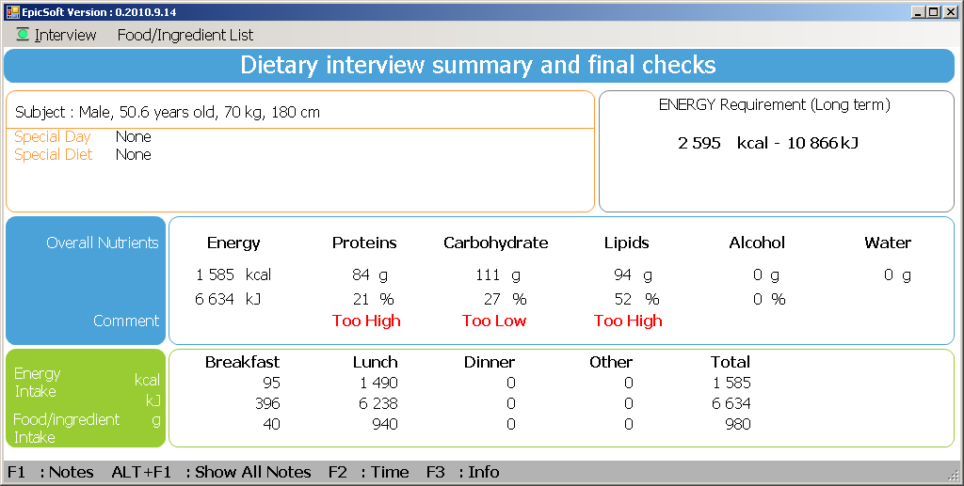

Interview menu

* DESCRIPTION/QUANTIFICATION (F9): enables to go back to the Description/quantification screen to correct some data

* NEXT INTERVIEW STEP: enables to proceed

Food/ingredient list menu

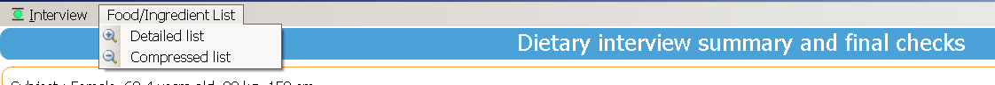

* DETAILED LIST: enables to list the quantities of all the foods and ingredients reported during the interview and their food groups.

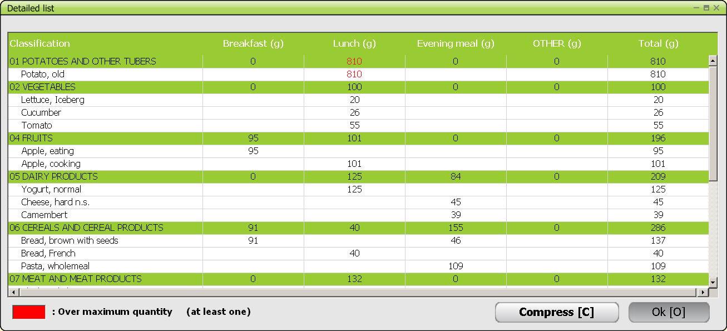

* COMPRESSED LIST: enables to list the quantities of each food group to which all the foods and ingredients reported during the interview belong.

In both lists, quantities which exceeded the maximum values are written in red.

Note: the detailed and compressed are linked together and one can switch from one to the other by pressing ‘Compress’ or ‘Decompress’. ‘OK’ enables to escape from these screens.

- VITAMINS AND OTHER SUPPLEMENTS

At the end of the interview, the information about the vitamins or other supplements (or any medication containing vitamins, minerals, ...) that have been consumed will have to be completed. They can be linked to existing FCOs or to additional FCOs or an unspecified FCO. The latter is automatically entered in the FCO list.

The information entered during the Quick list step (Chapter IV 2.4) is proposed as a help to fill the DIETARY SUPPLEMENT DESCRIPTION AND QUANTIFICATION screen in NEW interview mode.

INTERVIEW menu

Availability of functions will depend on the setting.

* ADD OCCASION (F5): allows the addition of a FCO. Choose from the pre-defined list and enter the time and place of consumption

* DELETE OCCASION (F6): allows the deletion of the FCO on which the cursor is, if this FCO was empty. Else a warning ‘Sorry, the FCO item cannot be deleted’ is prompted.

* MODIFY OCCASION: allows changing the time and place of consumption.

* RETURN IN DESCRIPTION/QUANTIFICATION (F9): allows going back to the description/ quantification screen

* END INTERVIEW: allows ending the interview. A question on whether to save the interview is asked.

SUPPLEMENT ITEMS menu:

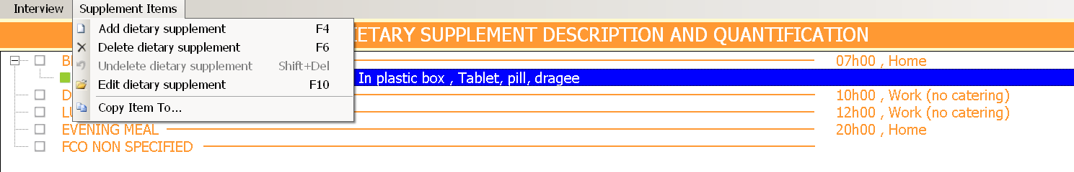

* ADD DIETARY SUPPLEMENT (F4): open the Search screen to select a Dietary supplement

* DELETE DIETARY SUPPLEMENT (F6): enables to delete the current Dietary supplement

* UNDELETE DIETARY SUPPLEMENT (SHIFT + DEL): Function allowing listing all the dietary supplements which have been deleted during the interview. To undelete an item, set the cursor on this item and select ‘OK’. The cursor will be set on the undeleted item in the DIETARY SUPPLEMENT DESCRIPTION AND QUANTIFICATION screen. ‘Cancel’ enables to leave this window without modification.

* EDIT DIETARY SUPPLEMENT (F10): enables to re-describe and re-quantify the current Dietary supplement

* COPY ITEM TO …: enables to copy a Dietary supplement into another FCO

In the ‘Search for’ screen:

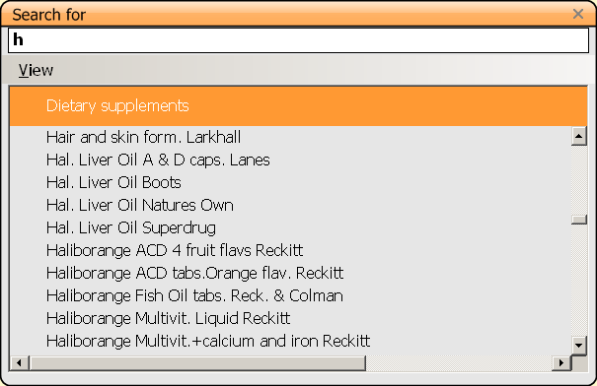

VIEW menu:

* ALPHABETICAL: This option displays the dietary supplement list classified in alphabetical order (default).

* GI AT BOTTOM: this option enables to have the generic items (ending by n.s.) reported at the bottom of the displayed list. Select again to de-activate.

* SEARCH: This function allows a search in the entire dietary supplement list for all the dietary supplements containing a given search string, whatever its position in the name. The search is done by default from the top of the list classified in alphabetical order. The dietary supplements in which the search string has been found are displayed in a separate window (see Chapter IV 3.4.2.).

* NEW SUPPLEMENT: This function can be used during the interview to add NEW dietary supplements reported by the subject but not available in the list. Classify the new item in its group/subgroup -if relevant-, and the facets and quantification methods defined for that group will automatically be shown. If the facet proposed by default is not relevant for describing the new dietary supplement entered, the option “undefined”, available systematically for each facet, should be selected.
After quantification, the NOTES SCREEN opens automatically in order to enter any additional information that the subject may give about the dietary supplement. All new dietary supplements entered during the interview will be flagged, for checking, after the interview, whether they need to be added officially in the dietary supplement database or not.

Note: In some countries, no prefined list will be available. Then the option ‘New supplement’ will be chosen each time.

Each selected dietary supplement will be described through a series of facets like foods and recipes.
The last facet relates to ‘quantification’.

- END OF THE INTERVIEW

Once the option ‘End interview’ is chosen in the Interview Menu, the question “do you want to save the interview?” is prompted on a window. ’
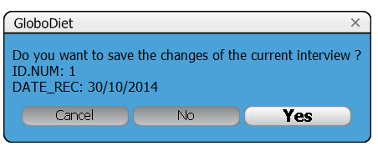

- Cancel’ enables to remain in GloboDiet.

- ‘No’ enables to quit the interview without saving it. A warning is displayed. ‘Cancel’ enables to remain in GloboDiet, when choosing ‘OK’ a message says the interview has not been saved. GloboDiet without saving the interview. Click ‘OK’. GloboDiet front page is displayed with the question ‘Do you want to exit GloboDiet?’.

- ‘Yes’ (SAVE) enables to save the interview. Messages saying the interview is being saved and then that the interview has been saved. Click ‘OK’. GloboDiet front page is displayed with the question ‘Do you want to exit GloboDiet?’

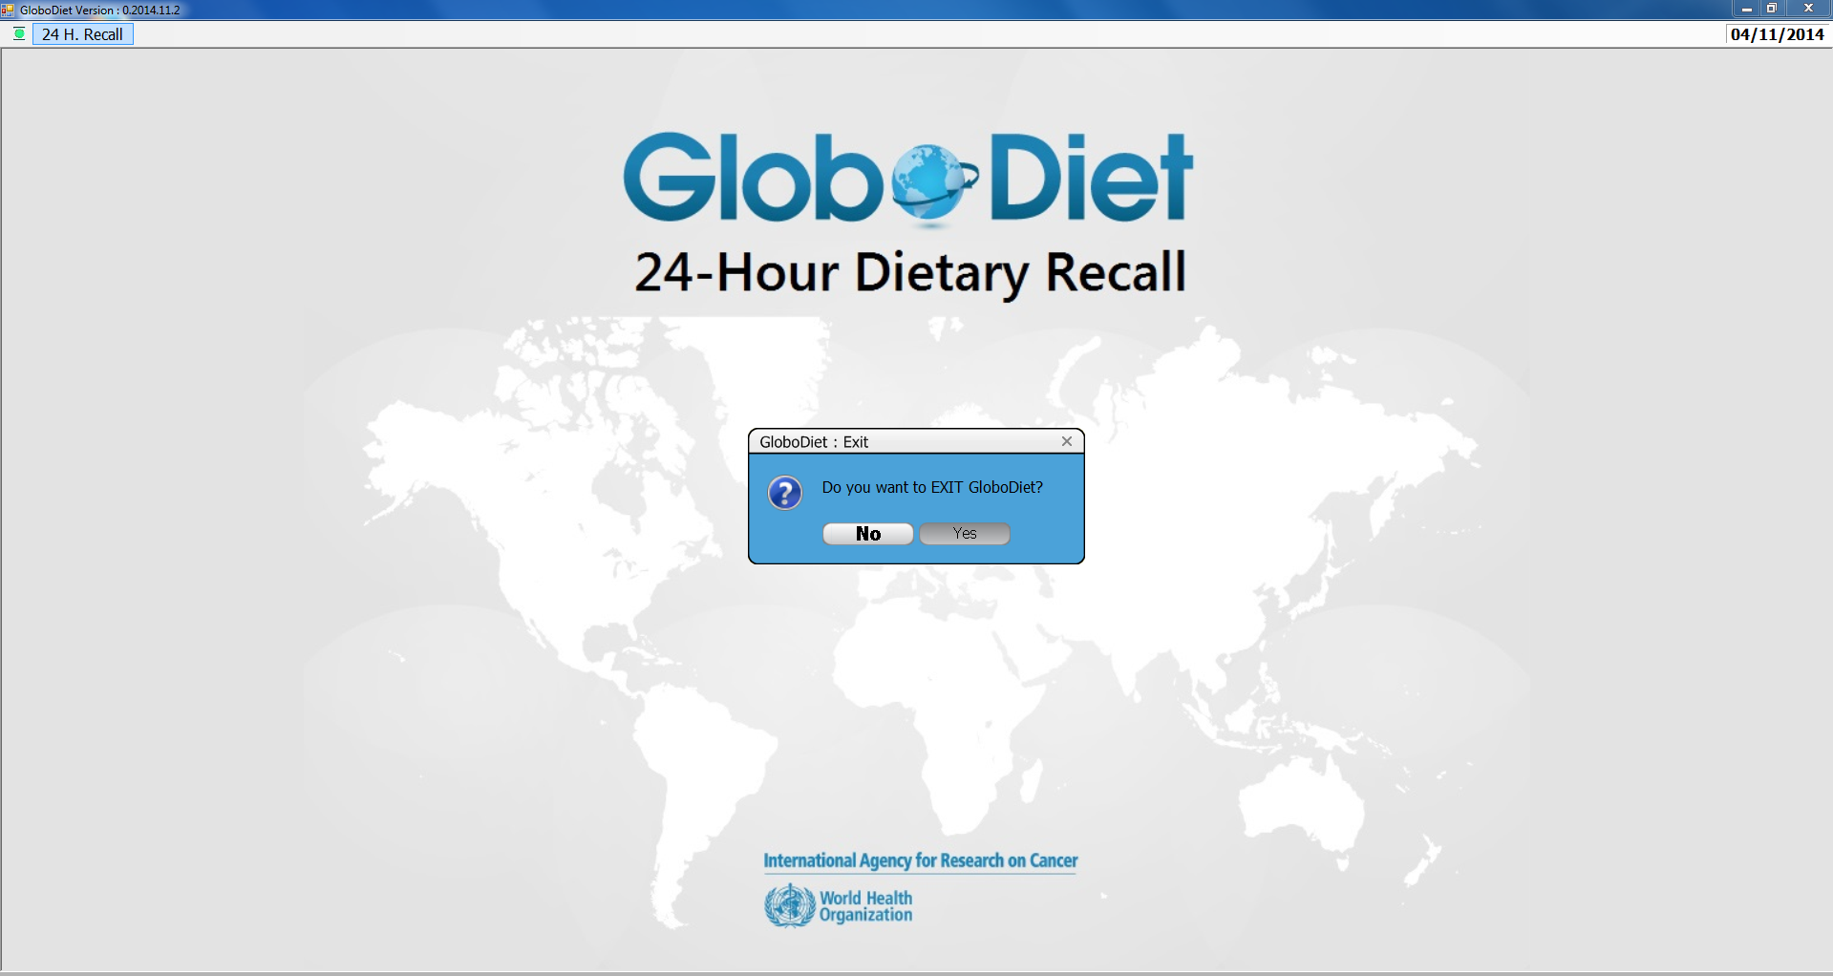

V PROCEDURE FOR EDITING AN INTERVIEW

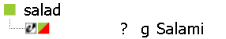
An already performed and saved interview can be edited directly in GloboDiet. This can be done by selecting the EDIT INTERVIEW option in the 24 H. RECALL menu after opening the application. The EDIT INTERVIEW mode is used to read, modify or up-date an interview already saved. The notes entered during the interview are an essential tool to upgrade and clean the interviews. A specific icon with a half of red square helps visualize items to be handled checked and/or corrected in EDIT interview mode.

CHOOSE AN INTERVIEW IN EDIT INTERVIEW MODE

After selecting the EDIT INTERVIEW mode, you will have to choose the interview to be edited. By default the interviews are ordered by ‘Location, Code and Interview number’.
In case of a long list, some functions are available:
- A Search field at the top of the screen can be used to type in a word/numeric string
- The following variables can be also sorted either alphabetically or numerically

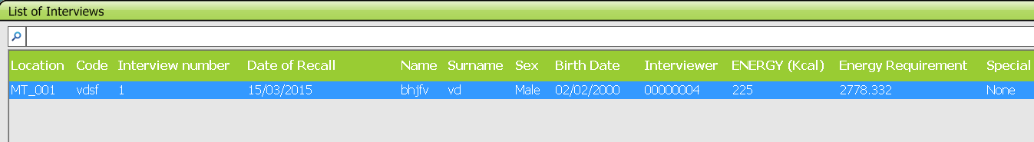

DIFFERENCES BETWEEN THE NEW AND EDIT INTERVIEW MODES

Edit mode is indicated in the top right corner of all the screens of the opened interview.

The procedure is the same as for a NEW interview, except for the following functions which are not available (or not active) in the EDIT mode:

- In the general information screens, interview date and subject’s code cannot be changed/corrected. This may be done outside GloboDiet.

- F2 TIME: this function which gives the duration since the beginning of the interview is not active in EDIT interview mode. The duration of the interview is available for information in the INTERVIEW INFO screen accessible with the key function F3 (INFO) or with the mouse (double click).

- QUICK LIST CHECK screen: The check screen on the empty food consumption occasions is not available in EDIT interview mode.

The main difference between the NEW and EDIT interview modes concerns the handling of recipes which is described in the paragraph V.5 (Handling of Recipes in Edit Interview Mode) below.

In some instances, changes in the GloboDiet database will be needed to clean further the collected data. Therefore receiving an updated parameters database (.bak) – e.g. new foods/recipes, facets/descriptors were added - will enable to finalise the data cleaning. However, modifying the collected data (i.e. responses from the subjects) should be kept to the minimum.

New foods/recipes reported during field work: the updated parameters database will enable you to select the corresponding foods/recipes according to the decisions made during data cleaning.

Update of the description of a food/ingredient/recipe: the updated parameters database will enable you to correct the description of your food/ingredient/recipe. GloboDiet will propose the previously selected descriptors. In case facets and/or descriptors have been removed, they will not be proposed any more. In case facets have been added, GloboDiet will propose them and you will have to provide a descriptor even though the interviewee did not provide the answer (the coordinators have to set rules – e.g. using of “undefined” descriptor). In case descriptors have been added, GloboDiet will propose the descriptor selected during the interview. You will be able to select from the newly added descriptors list.

Update of the quantification of a food/ingredient/recipe: the updated database will enable you to correct the quantification of your food/ingredient/recipe. To avoid going through (and changing) the description, please select “Modify quantity F10” function. Note that for recipes in particular, this new ingredient quantity is “as estimated” and for the whole recipe.

HANDLING OF NOTES

Handling of notes: in NEW interview mode, generated notes are automatically given the status ‘new’.

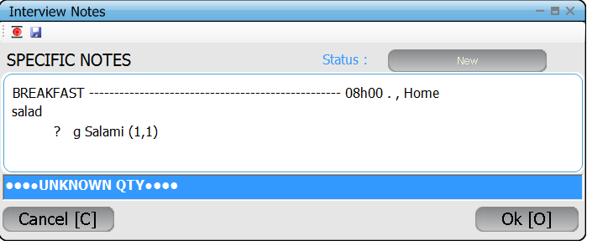
In EDIT interview mode, after having updated the interview item, you can update its status. First click on the updated interview item with a note in order to select it. Then press F1, and choose ‘specific notes’ to view the note. Then click on the status ‘new’, which will allow you to select from a pop up list the new status by double clicking on it. Alternatively, status of the notes can be done in the exported NOTES file (in Excel) and in the future will be done in the Interview Manager application.

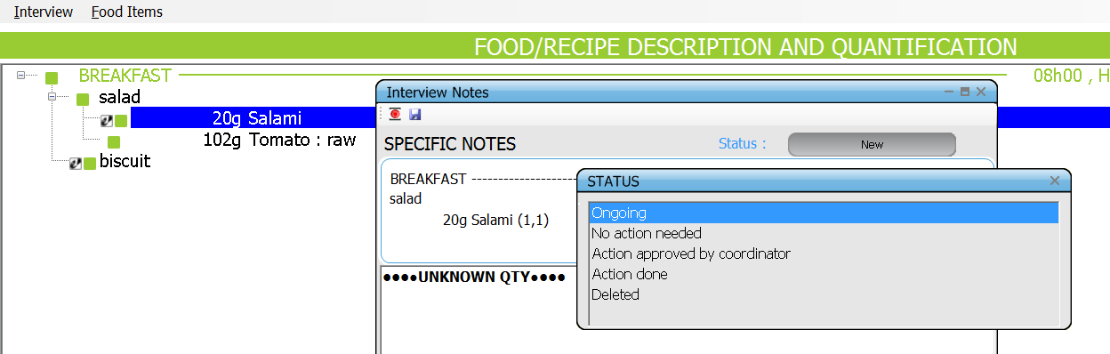

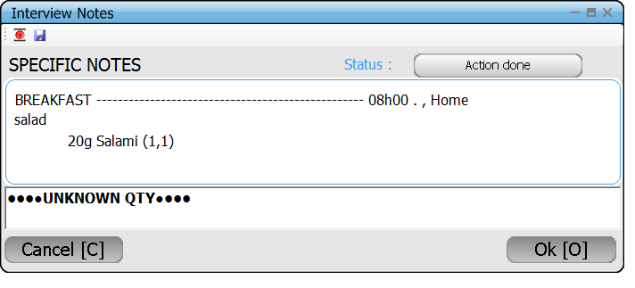
The item remains flagged, the notes are unchanged but the status of its attached note is changed.

Reminder: Alt F1 allows one to view all the interview notes and their status. It can be useful when verifying which notes have been handled and which have yet to be updated.

MODIFY A FCO

If the hour or the place of the existing FCO needs to be modified, this can be done in EDIT mode by selecting the FCO in the QLI screen and either press F8 key or click on Functions, then Edit/Modify.

If a given FCO has to be replaced by a different FCO, for example if “Before breakfast” has been erroneously selected instead of “Breakfast”, a few steps will need to be taken to ensure that all the reported food/recipe items under the original FCO are moved to the new FCO:
First, in the QLI screen, enter the new/correct FCO, in our case “Breakfast”, with its place and time, by either pressing F5 or clicking on Functions, then Next Occasion.
Under this FCO, the same quick list items need to be entered manually as the ones already defined in the previously selected FCO. In our example, those entered in FCO “Before breakfast”. Then in Description/quantification screen, all the foods/recipes&ingredients under the original FCO (i.e. “Before breakfast” need to be copied into each of the quick list items of the newly created FCO (i.e.“Breakfast”) using copy/paste function.

Note: Only foods/recipes&ingredients can be copied/pasted, not the quick list items, which need to be entered in the QLI screen. To finish, and once all the food/recipe items have been copied and pasted, in the Quick list screen, you need to delete the original FCO (i.e. “Before breakfast”). All the attached quick list items, foods and recipes&ingredients will also be deleted.

HANDLING OF RECIPES IN EDIT INTERVIEW MODE

In EDIT interview mode, the RECIPE INGREDIENT MANAGER screen is dedicated to updating/cleaning recipes reported during the interview, which would be flagged in red. Therefore it is possible to add, delete, redescribe and requantify each ingredient. The recipe name and classification may be changed by selecting ‘Recipe Groups/Subgroups’ in the Ingredients menu. A Help recipe may be chosen from the recipe list.

Modification of a recipe

Due to information entered in the NOTE file or because of difference in brands etc., the coordinator may decide to update a recipe.
In the Food Items menu click on the recipe to be modified and then choose Edit (F8) to open the ‘Recipe ingredient manager’.
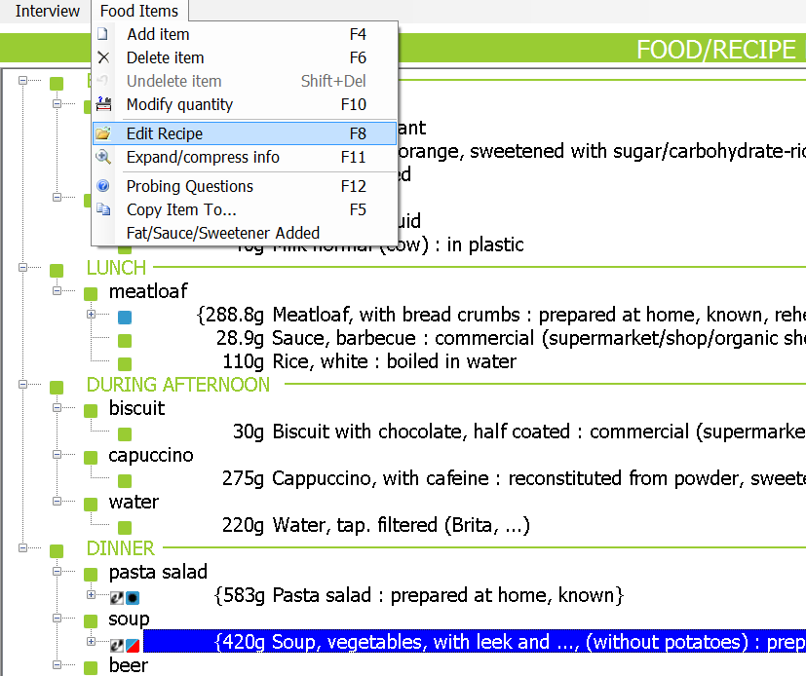

From the ‘Recipe ingredient manager’ screen choose a function in the Ingredients menu. In EDIT INTERVIEW mode, all functions are accessible no matter the recipe type.

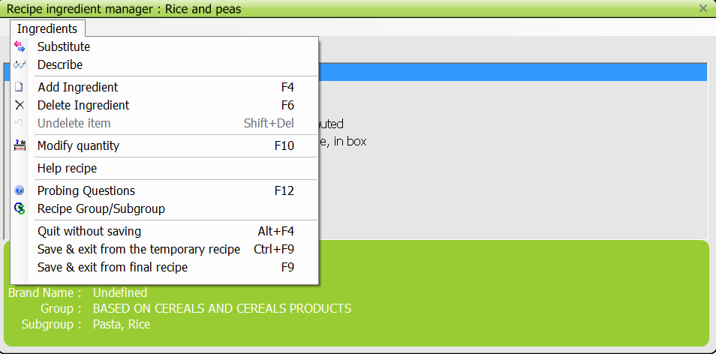

INGREDIENTS menu

* SUBSTITUTE: This option is active for any ingredient on which the cursor is focused, allowing the food to be substituted by another food as described in 3.5.3. An alternative is to press the “enter/return” button.

* DESCRIBE: Option allowing going into the description of any ingredient and updating it. An alternative is to press the “enter/return” button.

* ADD INGREDIENT (F4): Option allowing ingredients to be added. The added food is inserted under the ingredient the cursor is focused on. After selection of the function, the SEARCH FOR screen opens and the food can be selected from the list (see description SEARCH screen)

* DELETE INGREDIENT (F6): Function allowing an ingredient to be deleted.

* UNDELETE ITEM (SHIFT + DEL): Function allowing listing all the items which have been deleted (strikethrough). To undelete an item, set the cursor on this item and select ‘OK’. ‘Cancel’ enables to leave this window without modification.

* MODIFY QUANTITY (F10): The quantity of ingredients can be modified with this function without having to re-describe again. Note that this quantity is as estimated and for the whole recipe.

* HELP RECIPE: Function to display a standard recipe chosen from the recipe list in a separate window.

* PROBING QUESTIONS (F12): Function to display the checklist for missing ingredients attached to the recipe ingredient.

* RECIPE GROUP/SUB-GROUP: Option allowing the modification of the group/sub-group and the name of the mixed recipe actually displayed.

* QUIT WITHOUT SAVING (ALT F4): Exit without saving, so the changes are not kept.

* SAVE AND EXIT FROM THE TEMPORARY RECIPE (CTRL F9): Option to only save temporarily and exit. This enables to have the calculations done, then the recipe can be edited again and checked. The red flag on the recipe is kept to show some work might still need to be done on that recipe.

* SAVE AND EXIT FROM FINAL RECIPE (F9): Option to save and exit. Unless a missing quantity remains, the red flag of the recipe is turned to blue flag.

Specific case of OPEN recipes

When editing a recipe, it is advisable to first confirm the deletion of ingredients before updating further the flagged added ingredients.

* DELETED ingredients in standard recipes

In NEW INTERVIEW mode, the deletion of ingredients with cumulative quantities representing a % above a certain cut-off point is not taken into account during the interview: the ingredients remain in the recipe but appears strikethrough. These recipes flagged in red have to be reviewed by the coordinator.

In the example below, the ingredient ‘onion’ was deleted from the open recipe ‘Soup, vegetables, with leek…’ but its deletion has to be confirmed given that its proportion is above the cut-off.

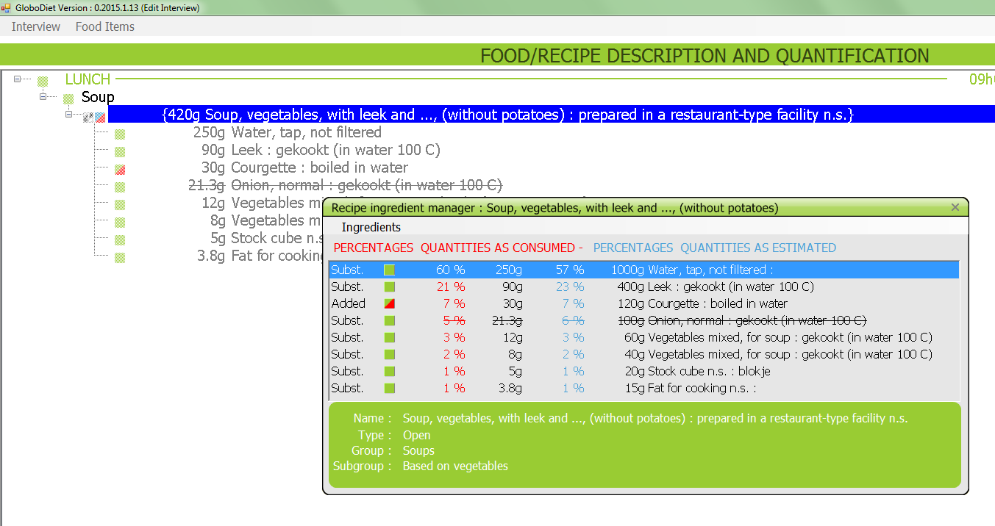

After verifying the recipe ingredients, the deletion of the ingredient is done by clicking on the ingredient and function F6. By saving and exiting from the recipe, the deletion of strikethrough ingredients will become effective.

Note that a temporary saving (CTRL F9) takes the entered modification into account (here deletion of item ‘onion’) but the red flag remains at the recipe level. Only a saving by F9 will consider the coordinator’s work as final by removing the red flag.

* ADDED ingredients to standard recipes

In NEW interview mode the addition of ingredients with cumulative quantities representing a % above a certain cut-off point is not taken into account during the interview: such ingredients would have a missing quantity (in g and %) next to it. A note would be created automatically to enable the verification of the quantities of the ingredients and the recipe itself. Such recipe is also flagged in red and needs to be edited.

In EDIT interview mode, on the other hand, the quantity of the added ingredient appears in the ‘Recipe ingredient manager’ screen. This should be verified by the coordinator for correctness and proper classification of the recipe.

In the example below, the ingredient ‘courgette’ was added to the open recipe ‘Soup, vegetables, with leek…’ and is flagged with a red sign and the consumed quantity represented a percentage above the cut-off.

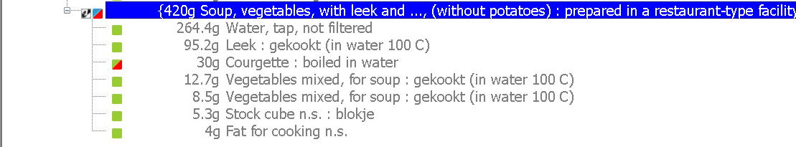

The quantity of the ingredient reported by the subject (i.e. as consumed) is integrated into the whole recipe. In the example below, the 30g of courgette consumed becomes 113.5g in the whole recipe, as estimated. These quantities have to be confirmed by the coordinator. If the quantity of the added ingredient is wrong, it is advisable to delete the ingredient first and add it back again with the correct quantity as estimated for the whole recipe.

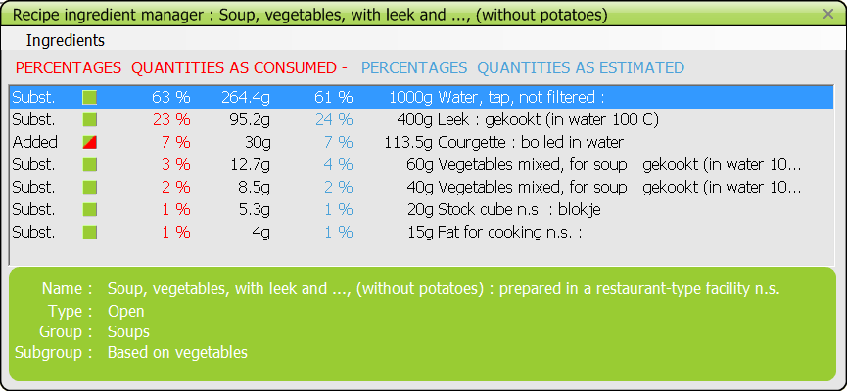

By temporarily saving the recipe (CTRL F9), the ‘Added’ ingredients are temporarily added to the recipe. This enables to see what the recipe would look like if the information from the subject was implemented as such. Saving by F9 will consider the coordinator’s work as final by removing the red flag.

Case of missing ingredient quantities:
In case the added ingredients still have missing quantities after editing, the recipe remains flagged with red even after saving with F9.

Temporary case of many added and deleted ingredients in recipes collected with EPIC-Soft:
In the past, EPIC-Soft enabled many changes. Note that GloboDiet no longer allows extreme changes to standard recipes in NEW interview mode (see in IV 3.9); it will not be able to handle cases where too many ingredients have been changed – and the modified recipe is far from the original one. To update such recipes entered with EPIC-Soft, we advise to create a new recipe by using a recipe from a cook book or from another source based on the individual information rather than trying to adapt the previous recipe.

In Edit interview mode, the best approach to manage the unknown recipes including added/deleted ingredients collected using EPIC-Soft (rather than GloboDiet) is:
- Open the interview.
- Copy first the recipe to be managed within the same quick list item (Ctrl-C & Ctrl-V)
- Open this copied recipe and delete the ‘deleted' ingredients (F6)
- Save the temporary recipe (Save & exit from the temporary recipe - Ctrl+ F9)
- Re-open this recipe and check that the added ingredient consumed quantities are coherent with the information reported in the Notes. If the displayed consumed quantities (and percentages) match:
  - THEN you can activate the final save function (Save & exit from final recipe - F9) and delete the original one created in new interview mode.
  - ELSE (if no match), you have to exit the recipe without saving and to delete it (this copied one). You can then create a new known recipe using a cook book and the subject information reported in the Note. Once this new recipe has been entered, you can delete the original one created in new interview mode.

